What is sexual harassment?
Sexual harassment means any unwelcome sexual behaviour that a reasonable person could anticipate may make another person feel offended, intimidated or humiliated in that situation.
Unwelcome behaviour means unwanted or uninvited behaviour that makes a person feel offended, embarrassed or frightened.
Whether behaviour is unwelcome is a question for the person harassed.
A ‘reasonable person’ can be taken to mean a neutral and unbiased observer.

Sexual harassment is not always obvious. It includes a wide range of behaviours. The most common behaviours are:
- sexually suggestive comments or jokes that offend or intimidate
- intrusive questions about a person’s private life or physical appearance
- inappropriate staring or leering
- inappropriate physical contact
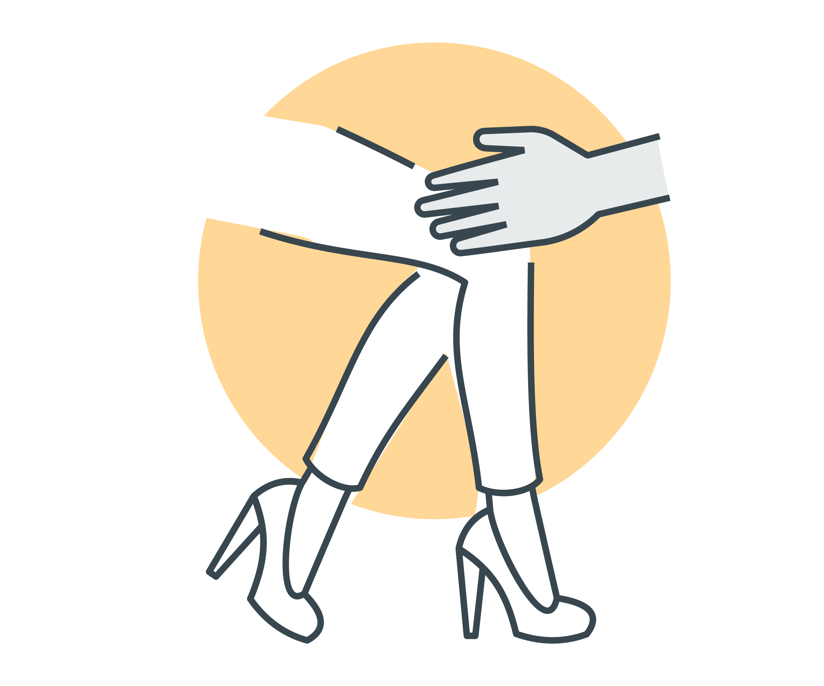
- unwelcome touching, hugging, cornering or kissing.
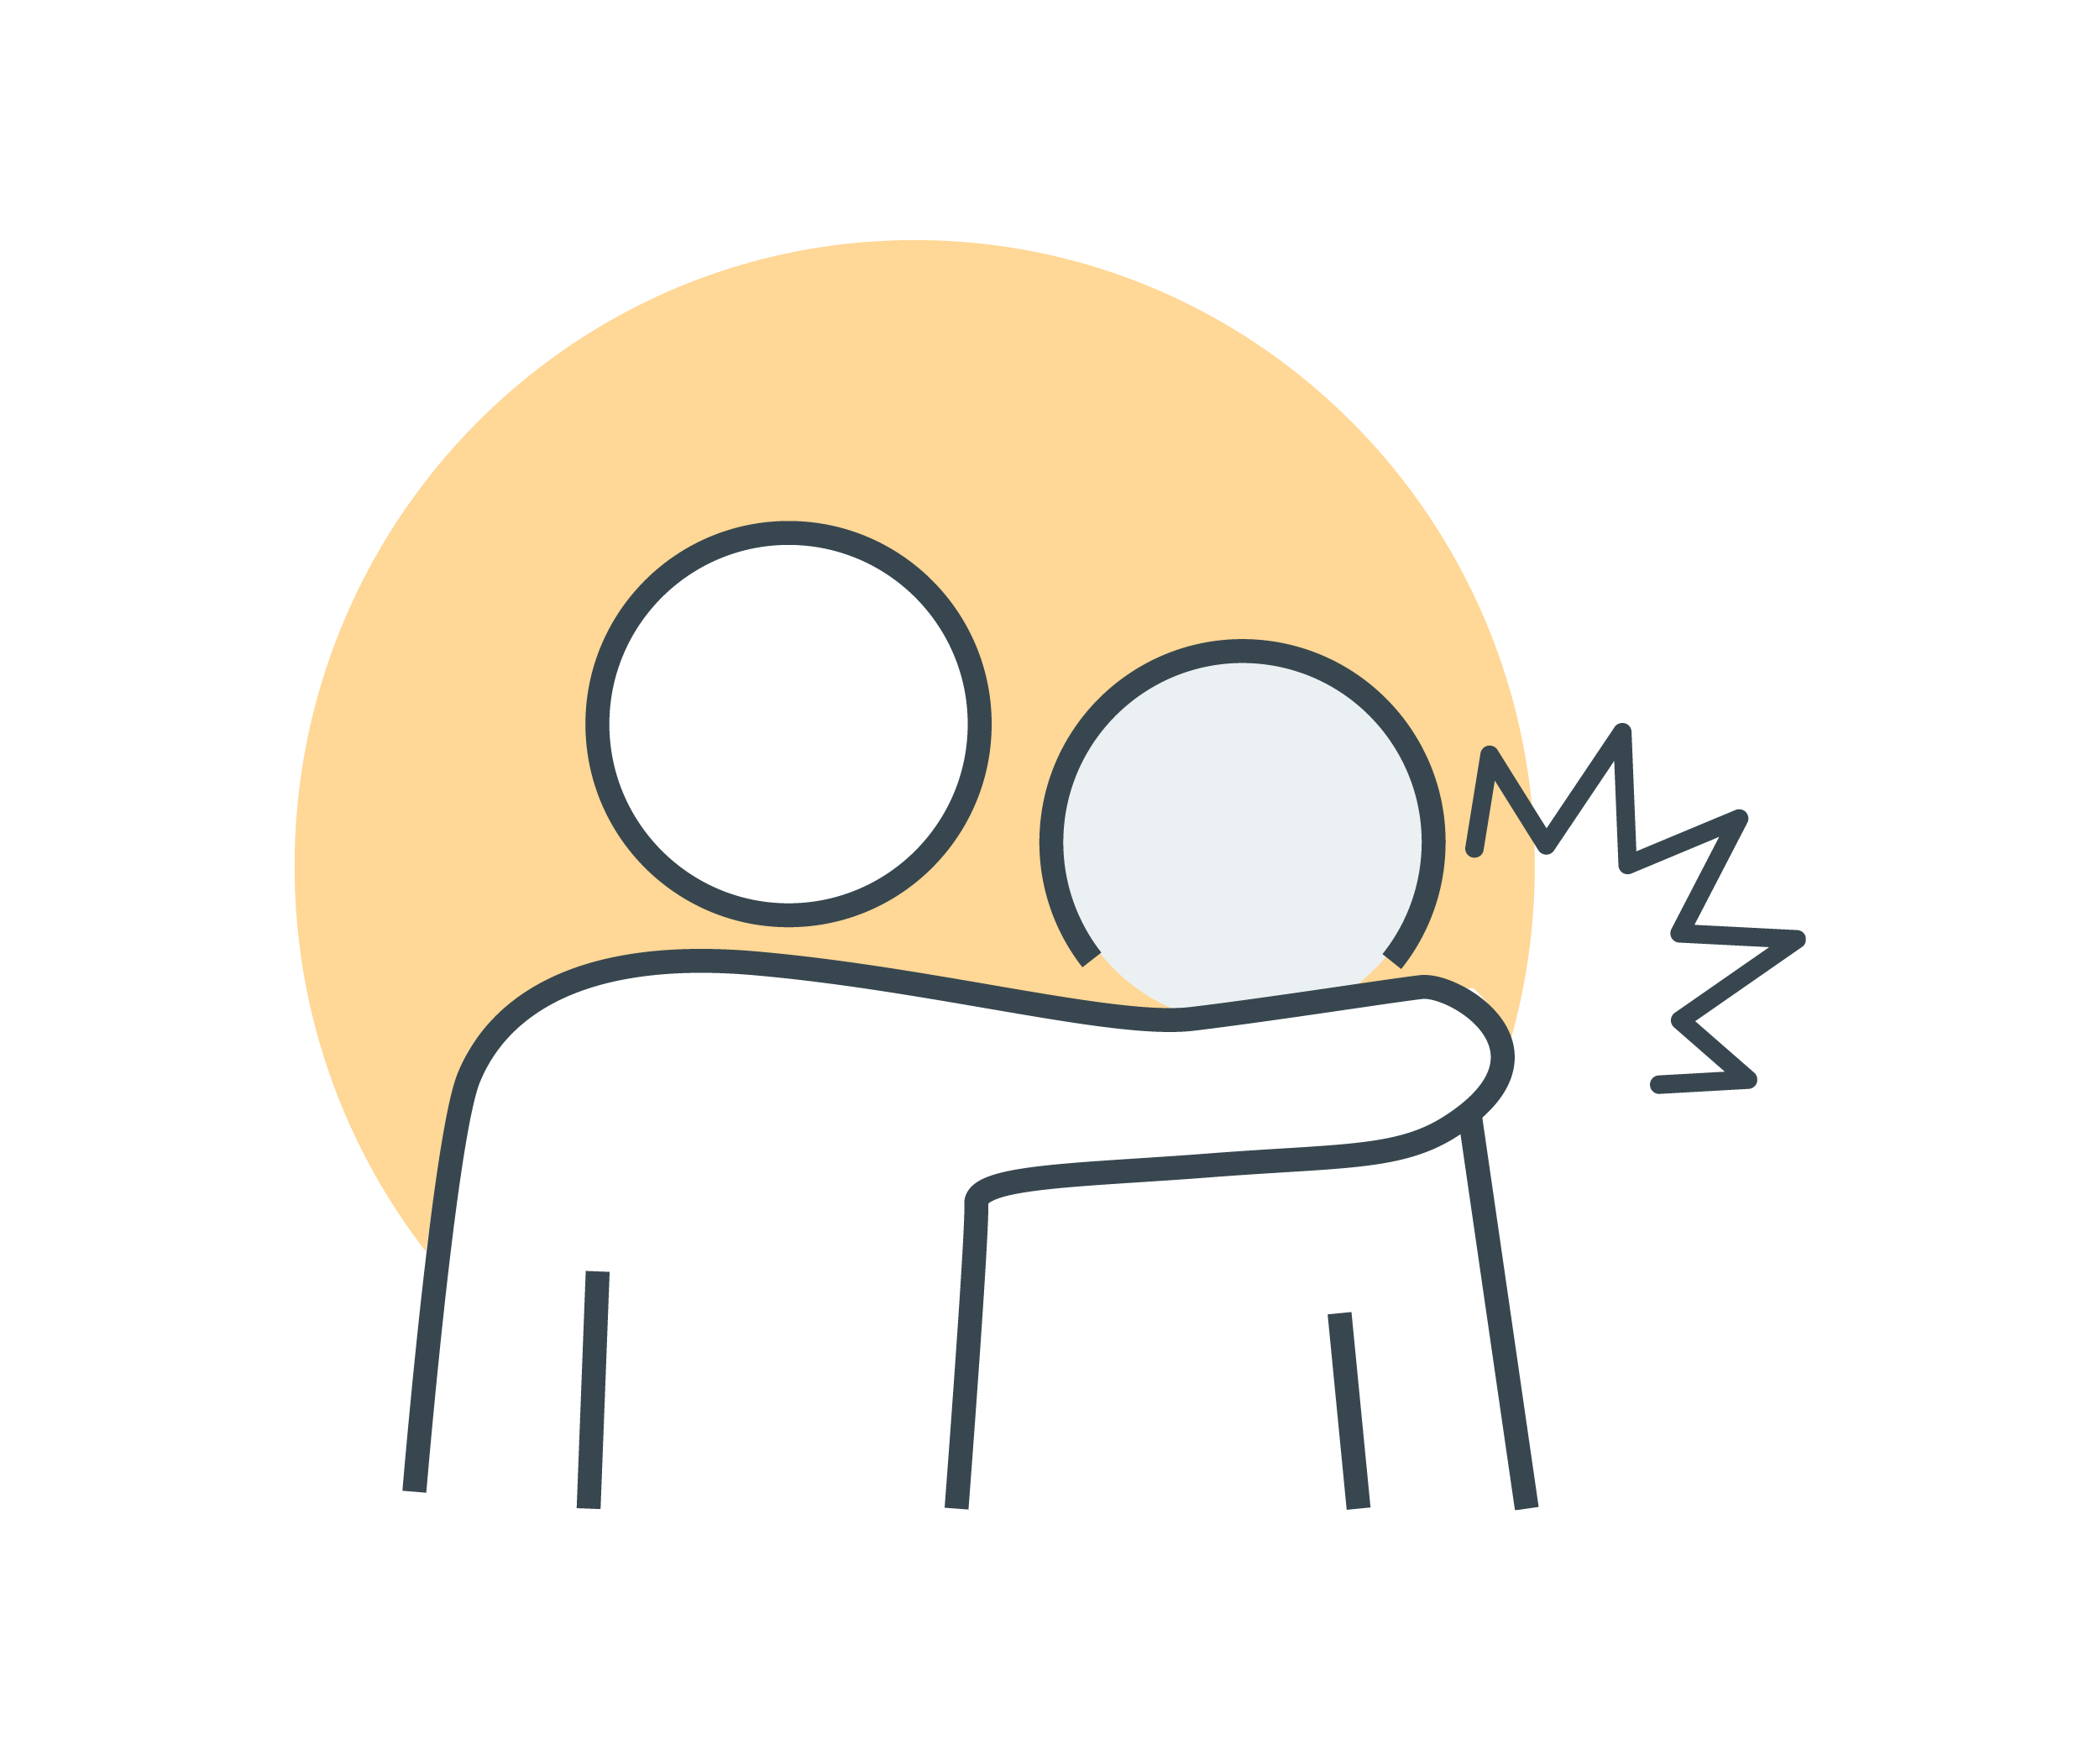
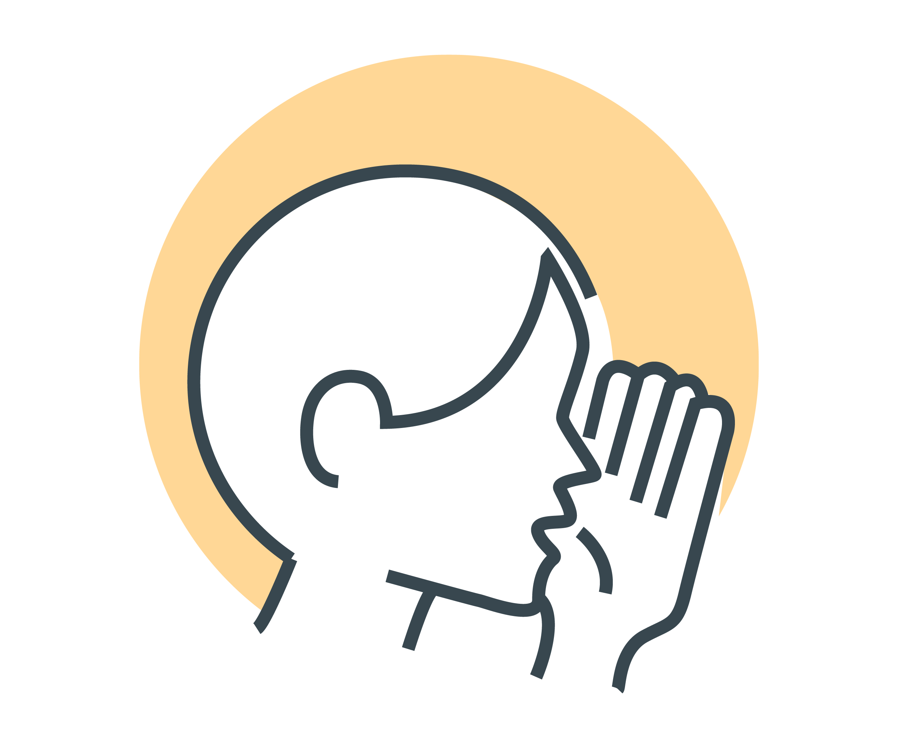
Other examples of sexual harassment include:
- sharing or threatening to share intimate images or video without consent
- repeated or inappropriate invitations to go out on dates
- requests or pressure for sex or other sexual acts
- sexually explicit gifts, images, videos, cartoons, drawings, photographs, or jokes
- actual or attempted rape or sexual assault
- sexually explicit comments made in person or in writing, or indecent messages, phone calls or emails—including the use of emojis with sexual connotations
- sexual gestures, indecent exposure or inappropriate display of the body.
Sexual harassment happens in person, over the phone and online, including via social media.

