## In this document:

1. The definition of sexual harassment
2. The definition of workplace sexual harassment
3. Other workplace rights

Sexual harassment is a human rights issue; it is also a workplace hazard that is known to cause psychological and physical harm.

There are a number of laws at the federal, state and territory, and international levels that are relevant to workplace sexual harassment, including:

* The *Sex Discrimination Act 1984* (Cth) (“Sex Discrimination Act”)
* The *Fair Work Act 2009* (Cth) (“Fair Work Act”)
* State and territory anti-discrimination, equal opportunity and human rights laws
* Commonwealth, state and territory Work Health and Safety (WHS) laws
* Commonwealth, state and territory workers’ compensation laws
* Criminal law
* Convention on the Elimination of All Forms of Discrimination Against Women.

These laws seek to create safer and more respectful workplaces.

# Definition of sexual harassment

Australian law states that sexual harassment occurs when:

* 1. a person makes an unwelcome sexual advance, or an unwelcome request for sexual favours, to the person harassed; or
  2. engages in other unwelcome conduct of a sexual nature in relation to the person harassed;

in circumstances in which a reasonable person, having regard to all the circumstances, would have anticipated the possibility that the person harassed would be offended, humiliated or intimidated.

This definition is used in the Sex Discrimination Act and Fair Work Act and is also recognised in WHS codes of practice.

There are three components of this definition:

1. Conduct of a sexual nature.
2. Conduct that is unwelcome.
3. Conduct that a reasonable person would anticipate the possibility of causing offence, humiliation, or intimidation.

## 1. Conduct of a sexual nature

Sexual harassment can take many forms. The Courts have interpreted 'conduct of a sexual nature' as including a wide range of behaviours and have emphasised the importance of looking at context when assessing the relevant conduct. The most common behaviours are:

* sexually suggestive comments or jokes that offend or intimidate
* intrusive questions about a person’s private life or physical appearance
* inappropriate staring or leering
* inappropriate physical contact
* 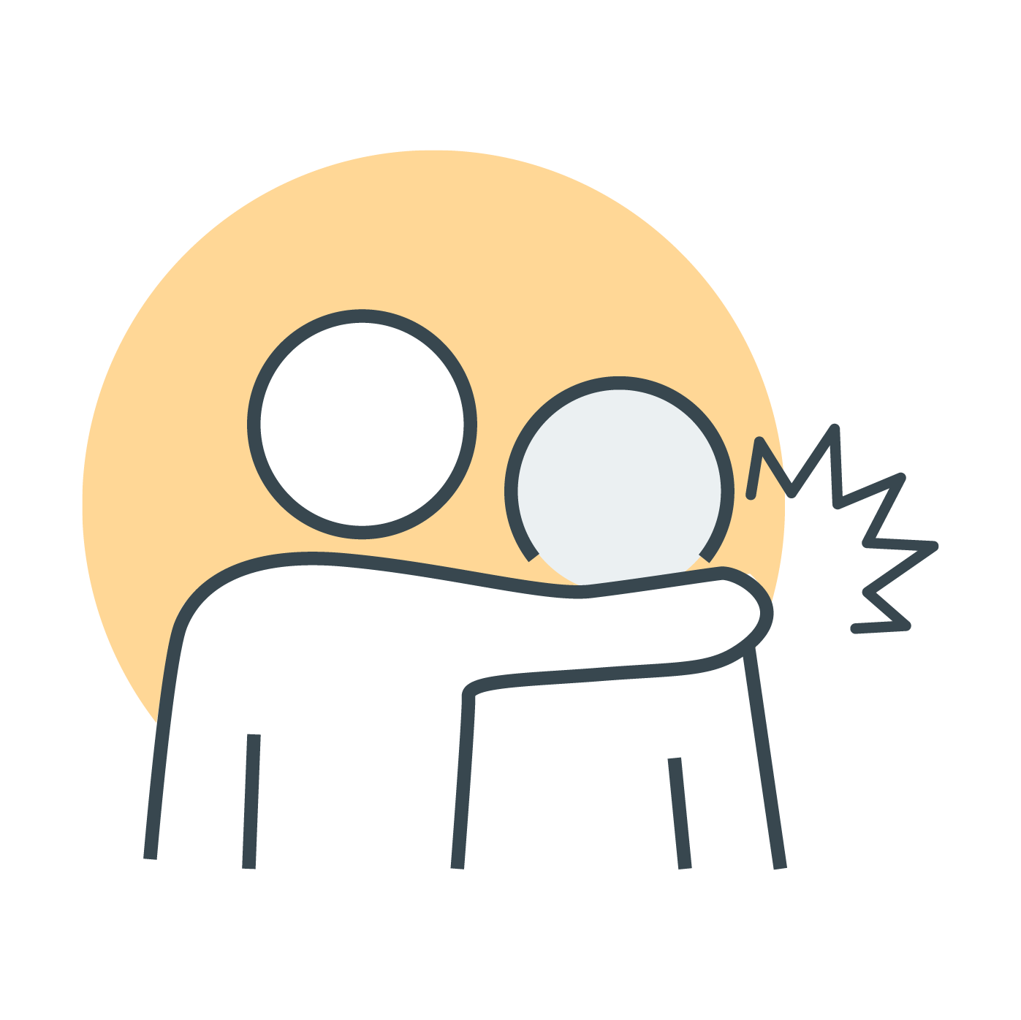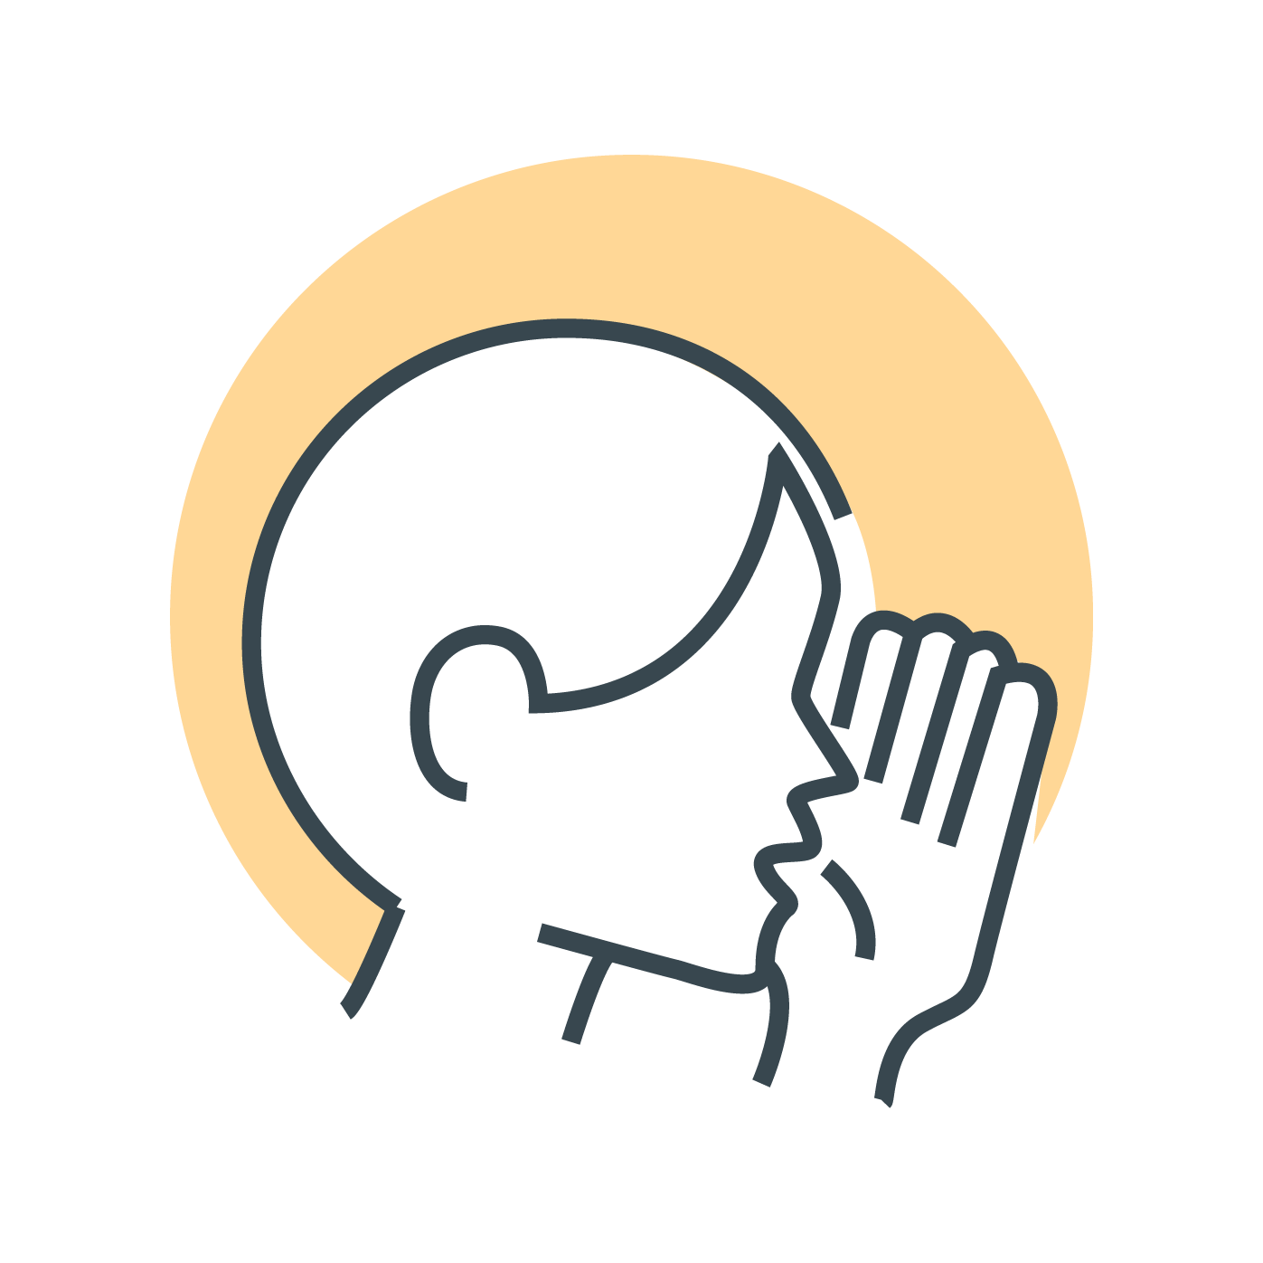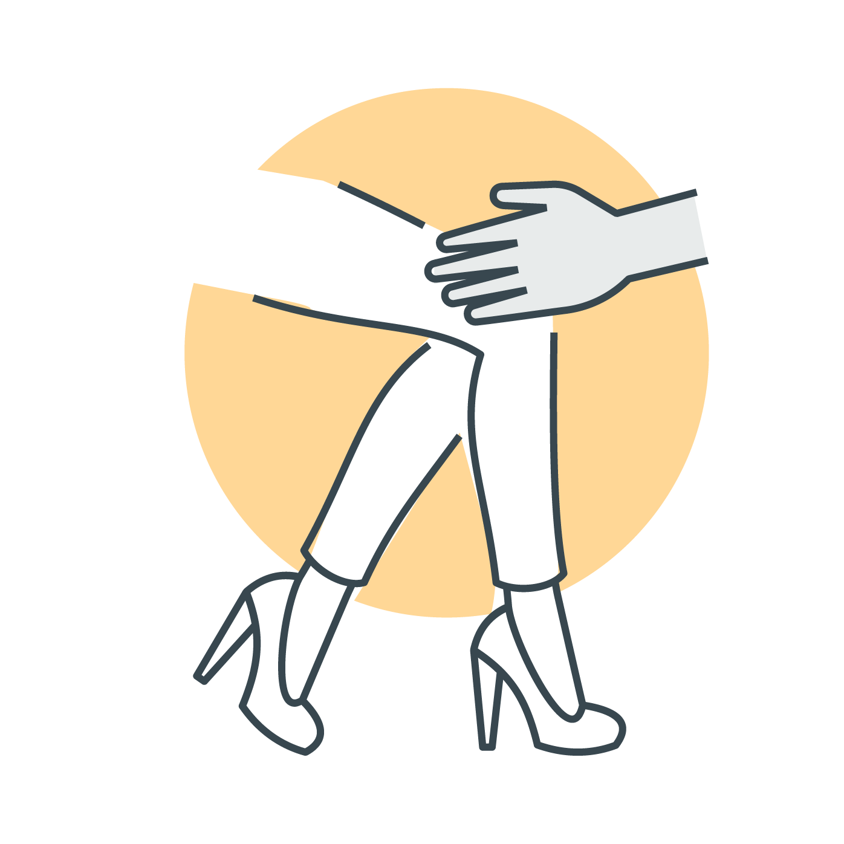unwelcome touching, hugging, cornering or kissing.

Other examples of sexual harassment include:

* sharing or threatening to share intimate images or video without consent
* images or videos that are sexually suggestive or that constitute a sexual advance
* repeated or inappropriate invitations to go out on dates
* requests or pressure for sex or other sexual acts
* sexually explicit gifts, images, videos, cartoons, drawings, photographs, or jokes
* actual or attempted rape or sexual assault
* being followed or watched inappropriately, or someone loitering inappropriately, either in person or via technology
* sexually explicit comments made in person or in writing, or indecent messages, phone calls or emails—including the use of emojis with sexual connotations
* sexual gestures, indecent exposure or inappropriate display of the body
* technology-facilitated unwelcome conduct of a sexual nature—including on virtual meetings
* repeated or inappropriate advances on email or other online social technologies.

Sexual harassment is not always obvious, repeated or continuous. It can include one-off incidents, or it can include a pattern of behaviour that makes the working environment uncomfortable or threatening in a sexually hostile way, such as displaying sexually offensive pictures, figurines or gifts, or a culture of suggestive comments or jokes.

Sexual harassment does not have to be directed at a specific person. It can also affect people who are exposed to or witness it (for example, overhearing a conversation between colleagues or seeing a colleague’s sexually explicit screensaver).

Sexual harassment happens in person, over the phone, and online—including via social media.



What does the law say?

In determining whether an advance, request or other conduct may be sexual in nature, **the intention of the alleged harasser is not relevant**. An advance, request or other conduct may be sexual in nature even if the person engaging in the conduct does not have a sexual interest in that person or is of a different sexual orientation to the person harassed.

## 2. Unwelcome conduct

Unwelcome conduct is behaviour which has not been invited or solicited by a person, and which the recipient regards as undesirable, offensive or disagreeable.

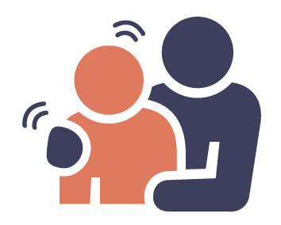Whether the behaviour is unwelcome is a **subjective question** from the **perspective of the person alleging sexual harassment**. The behaviour may still be unwelcome even where it:

* may not have been unwelcome to others
* has been accepted behaviour in the work environment in the past
* was not intended to be sexual or to offend, humiliate or intimidate.

This concept is important because not everyone in a workplace will have the same understanding of what is ‘acceptable behaviour’. Additionally, opinions can change and **conduct can become unwelcome at any time.**

It is also not necessary for the person harassed to have explicitly addressed the behaviour or informed their alleged harasser that the behaviour is unwelcome.

## 3. Conduct that a reasonable person would anticipate the possibility of causing offence, humiliation, or intimidation

The final element of the legal definition of sexual harassment considers whether the behaviour occurred in circumstances in which a reasonable person would anticipate the possibility that such conduct would offend, humiliate, or intimidate the person harassed.

What does the law say?

This is an objective test modelled on a test from Queensland’s *Anti-Discrimination Act 1991*. It asks what an independent and reasonable third party would have thought the complainant could feel given the overall context.

The list of circumstances a court considers to determine this includes:

* the sex, age, sexual orientation, gender identity, intersex status, marital or relationship status, religious belief, race, colour, national or ethnic origin of the person harassed
* the relationship between the parties involved
* any disability of the person harassed.

Whether a reasonable person would anticipate the possibility of offence, humiliation or intimidation may differ based on personal characteristics, as well as the relationship between the people involved.

In Australia, workplace sexual harassment is against the law.

# Definition of workplace sexual harassment

Sexual harassment is against the law in a number of areas of ‘public life’, including the workplace.

## Prohibition on workplace sexual harassment

Sexual harassment is against the law if it occurs:

* between individuals who have a particular workplace relationship, or
* during work, or in connection with work.

### Workplace relationships

Sexual harassment is against the law within specific work relationships, regardless of where the conduct occurs. Under the Sex Discrimination Act, it is against the law:

* to sexually harass an employee, or a prospective employee;
* for an employee to sexually harass a fellow employee, or a person seeking employment with the same employer;
* for a person conducting a business or undertaking to sexually harass a worker in that business or undertaking, or a person seeking to become a worker in that business or undertaking
* a worker in a business or undertaking to sexually harass a fellow worker in that business or undertaking, or a prospective worker.

Who counts as a worker?

A ‘**worker’** is anyone who carries out work for an employer or business. This includes full-time, part-time and casual workers, workers on probation, contract-based workers, self-employed workers, interns, apprentices, students and volunteers (unless the organisation is run entirely by volunteers).

For sexual harassment involving these specified types of workers, as long as the relevant relationship is established, there is no requirement that the conduct occurs in connection with work.

### In connection with work

The law also prohibits sexual harassment that occurs in connection with work.

It is important to understand that, for the purpose of sexual harassment law, definitions of ‘work’, ‘workplace’ and ‘connected with employment’ extend beyond traditional office settings.

A ‘workplace’ is a place where work is carried out and includes any place where a worker goes, or is likely to be, while at work.

A workplace extends beyond a worker’s 'normal' workstation or 'usual' place of work. A ‘workplace’ can include:

* Common areas such as lifts, entrances, reception areas, corridors, kitchens and facilities.
* Working remotely/virtually from home or another location.
* Agency or on-call work, including travel to different environments and/or other people’s homes, to conduct work duties.
* Offsite and onsite conferences, training programs and any other professional development opportunities.
* Transportation (e.g. vehicles, vessel, aircraft), travel and accommodation arrangements when workers are travelling for work.
* Work social and networking events (e.g. after-work drinks), especially when arranged or supported by an employer.

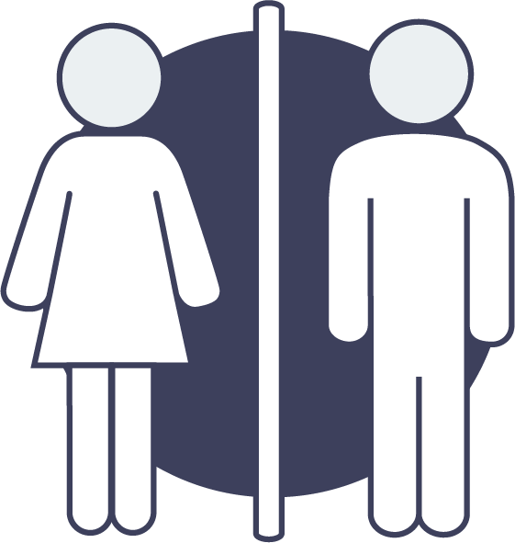

Workplace sexual harassment can be against the law even if it occurs outside a standard workplace environment, outside of normal working hours, and even while a worker is not ’at work’ or performing their duties (e.g. on a meal break, a work event or on a coffee break).

The Fair Work Commission has found that a worker can be at work even though they are not working (for example, because they are on an authorised meal break or at a work event or on a coffee break).

Individuals engaged in sexually harassing behaviour do not need to be fellow workers for legal protections to apply – for example, they could be customers or clients.

## Other workplace rights

The Sex Discrimination Act, Fair Work Act and model WHS laws protect workers from being punished, or treated unfairly, for asserting workplace rights. It is against the law for an employer to treat a worker unfairly, or to punish them, because they:

* made, or did not make, a complaint about workplace sexual harassment
* proposed to make a complaint
* helped someone else make a complaint
* raised an issue about sexual harassment in their workplace.

Some examples of unfair treatment include:

* ending your employment
* offering you fewer shifts or fewer hours
* not allowing you to attend training
* threatening you to try to stop you from making a complaint.

What does the law say?

The way the law provides these types of protections to workers differs under various pieces of legislation.

* Under the Sex Discrimination Act, ‘victimisation’ is against the law.
* Under the Fair Work Act, the ‘general protections’ laws provide protection to workers who make, or propose to make, complaints. The Fair Work Act also makes clear that ‘adverse action’ and ‘coercion’ are not permitted.
* Similar protections for workers also exist under the model WHS laws, which make it against the law for an organisation to disadvantage a worker who has raised a safety concern, such as sexual harassment.

# Workplace responsibilities

Work health and safety laws place responsibilities on organisations, workers and others in a workplace to take steps to prevent and address sexual harassment.

* **Employers** have a responsibility to do everything they reasonably can to make sure the workplace is safe. This includes taking action to prevent, and respond to, workplace sexual harassment.
* **Officers** (key decision makers) must exercise due diligence to ensure that the organisation complies with WHS obligations.
* **Workers** are responsible for taking reasonable care of their own health and safety while at work, and not negatively impacting the health and safety of others. This includes not sexually harassing others and following reasonable instructions from their employer.
* **Others** **in the workplace** (including customers, clients and patients) are responsible for taking reasonable care of their own health and safety, and not negatively impacting the health and safety of others. This includes not sexually harassing others and following reasonable instructions relating to health and safety.

For more information:

The Respect@Work website provides free information about workplace sexual harassment. To find out more, visit [respectatwork.gov.au](http://www.respectatwork.gov.au).

f5f2de