In this document:
- Gender inequality
- Other forms of discrimination and disadvantage
- Workplace settings and factors that increase risk
In order to effectively prevent workplace sexual harassment, we need to understand what causes it.
Workplace sexual harassment is primarily caused by imbalances in power.
Power relates to the possession of control, authority or influence over others.
Gender inequality is the key power imbalance that drives sexual harassment in Australian workplaces. However, other forms of discrimination and disadvantage also create power imbalances in the workplace.

Gender inequality
Gender inequality is the unequal distribution of power, resources, opportunity and value afforded to people in a society based on their gender.
Sexual harassment is considered a form of sex discrimination and gender-based violence. It can be experienced by everyone: women, transgender and gender-diverse people, and men. However, women, transgender and gender-diverse people experience gender-based violence at increased rates compared with men.
Sex and gender:
Sex describes the biological features that mean someone is anatomically male or female at birth. Gender is about one’s identity and one’s sense of whether they are a man, a woman, or whether they are non-binary. Gender is not biological, it is socially constructed and learned.

Gender norms
‘Gender norms’ are ideas about what is ‘normal’ in relation to gender. These are based on our assumptions and stereotypes of what it means to be a man or a woman. For instance, society generally expects a man to exhibit typically masculine traits such as ‘strength’, ‘assertiveness’ and ‘courage’. Similarly, we expect women to portray typically feminine traits such as ‘warmth’, ‘sensitivity’, and ‘empathy’—these gender norms carry into our everyday lives and shape the society that we live in.
There is powerful social pressure to comply with gender norms. People who do not always conform to these stereotypical ideas of what it means to be a man or woman face increased rates of workplace sexual harassment.
Studies have consistently found that men who are considered to have violated stereotypical masculine gender norms, such as by being ‘weak’, ‘gay’, ‘effeminate’ or in some other way ‘not man enough’ are more likely to be sexually harassed, and that this harassment is more likely to come from other men than from women.

Gender norms in the workplace
Gender norms shape our relationship to work. For instance, they shape our beliefs about which careers are better suited to a particular gender or how we expect people to behave based on their gender.
Many sectors which are perceived to require attributes like ‘strength’ tend to be male-dominated (e.g. construction), while those that require attributes like ‘empathy’ tend to be female-dominated (e.g. nursing).
These rigid ideas about men’s and women’s roles can be problematic, denying career opportunities for many. They can cause harm for women, since traditional female roles are commonly undervalued compared with men’s. This undervaluing of traditional female roles contributes to women’s lower wages and economic insecurity.
The pressure to conform to rigid gender norms can also cause harm for men and gender-diverse people.

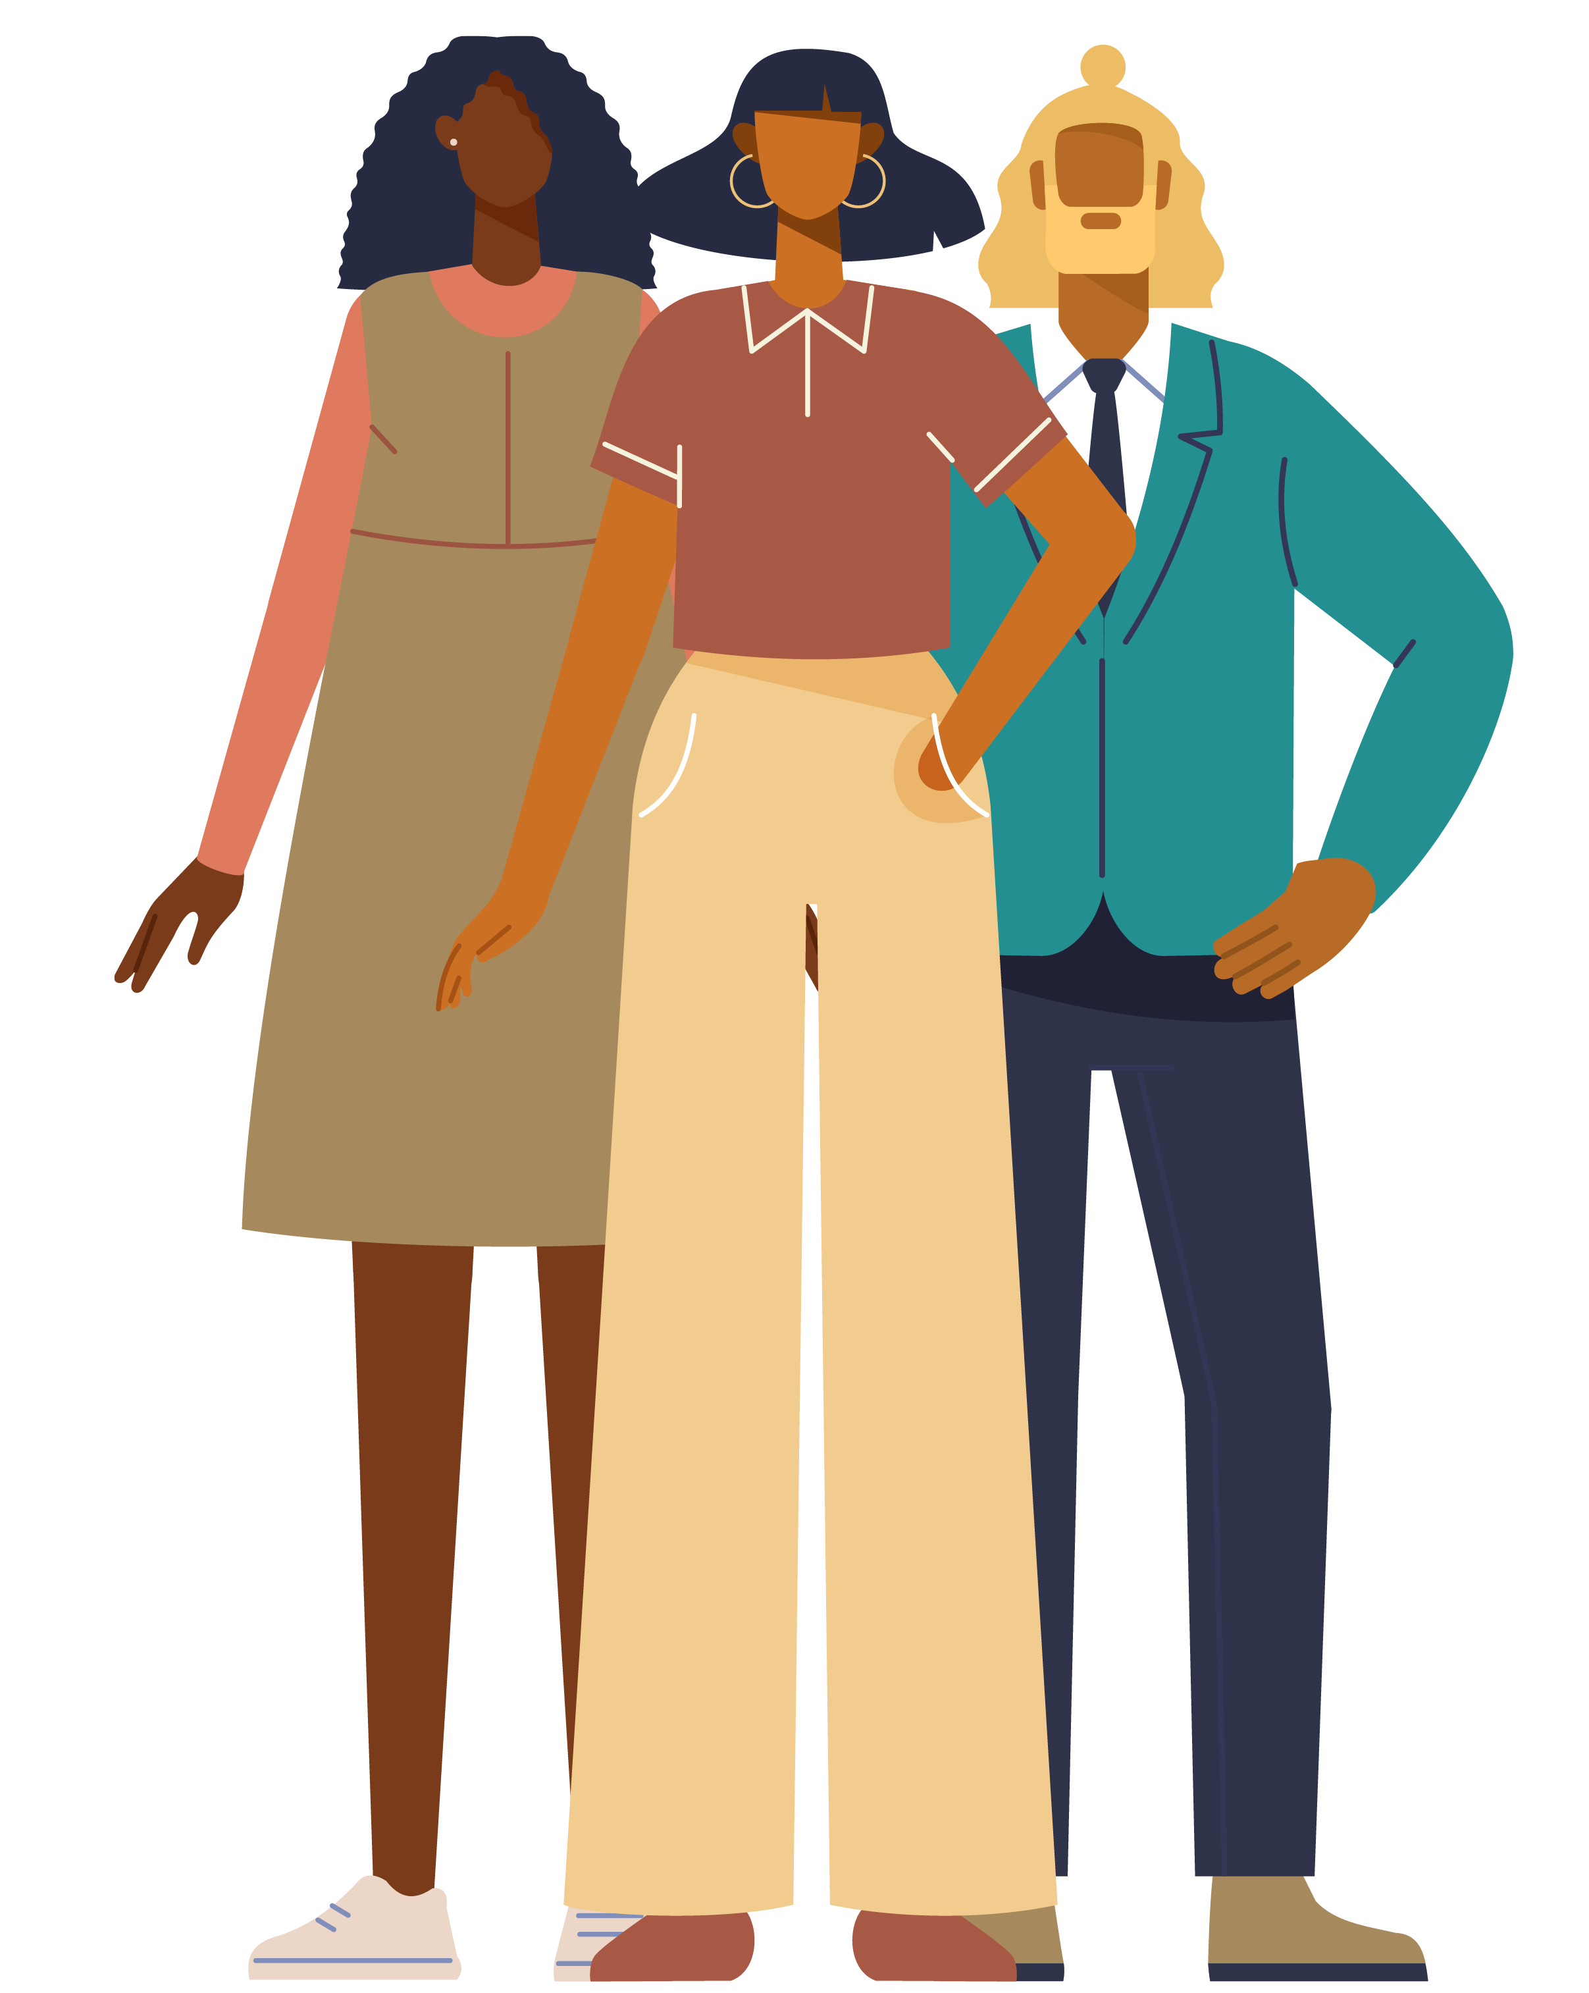
Women and girls make up 51% of the Australian population and roughly 47% of all Australian employees. However, they continue to face inequalities in the workplace.
For example:
- There are fewer women than men in full-time work
  - 38% of full-time employees are women
  - 62% of full-time employees are men.
- There are more women than men in part-time work
  - 68% of part-time employees are women
  - 32% of part-time employees are men.
- Women’s weekly full-time earnings are $255 less than men’s
- Women are under-represented in senior leadership positions in the Australian workplace, accounting for:
  - 18% of CEOs
  - 32% of key management personnel.
- Women comprise a substantial proportion of the workplace in lower-paid ‘caring’ industries such as:
  - social assistance services (81%)
  - residential care services (80%).
- Women are under-represented in Australian parliaments, accounting for 41% of Australian parliamentarians.
While there is limited Australian research on workplace inequalities for trans and gender-diverse people, we do know that they also face significant inequalities and discrimination in the workplace. International research highlights the flow-on effects of this on unemployment rates and low earnings.
Why is this important? These examples demonstrate that, as a group, women, trans and gender-diverse people have significantly less economic security, seniority, and influence than men. In the workplace, as in society, the balance of power resides with men.

Gender inequality begins outside of the workplace and plays out in our society through our attitudes, our beliefs, and our behaviours.
In many cases these attitudes, beliefs and behaviours are not obvious; they live below the surface and contribute to a society that accepts the disrespect of women, trans and gender-diverse people, driving behaviours like sexual harassment.
While disrespectful attitudes and behaviours may begin at home or in our private lives, they enter the workplace and can lead to hostile working environments in which gender inequality is normalised. Research clearly demonstrates that gender inequality is a key driver of workplace sexual harassment. Women, and people who do not conform to traditional gender roles, are more likely to be sexually harassed than men.

Other forms of discrimination and disadvantage
While gender inequality is a key driver of workplace sexual harassment, it is not the only factor. Other forms of inequality and disadvantage also create power imbalances in the workplace.
Power disparities in society also stem from a range of other factors, including race, disability, age, visa status, economic vulnerability, geographic location and career stage. Often, in cases of workplace sexual harassment, there may be multiple power imbalances at play. These can intersect with one another and increase the power imbalance between the person harassed and harasser. This can drive the misuse of power by harassers.
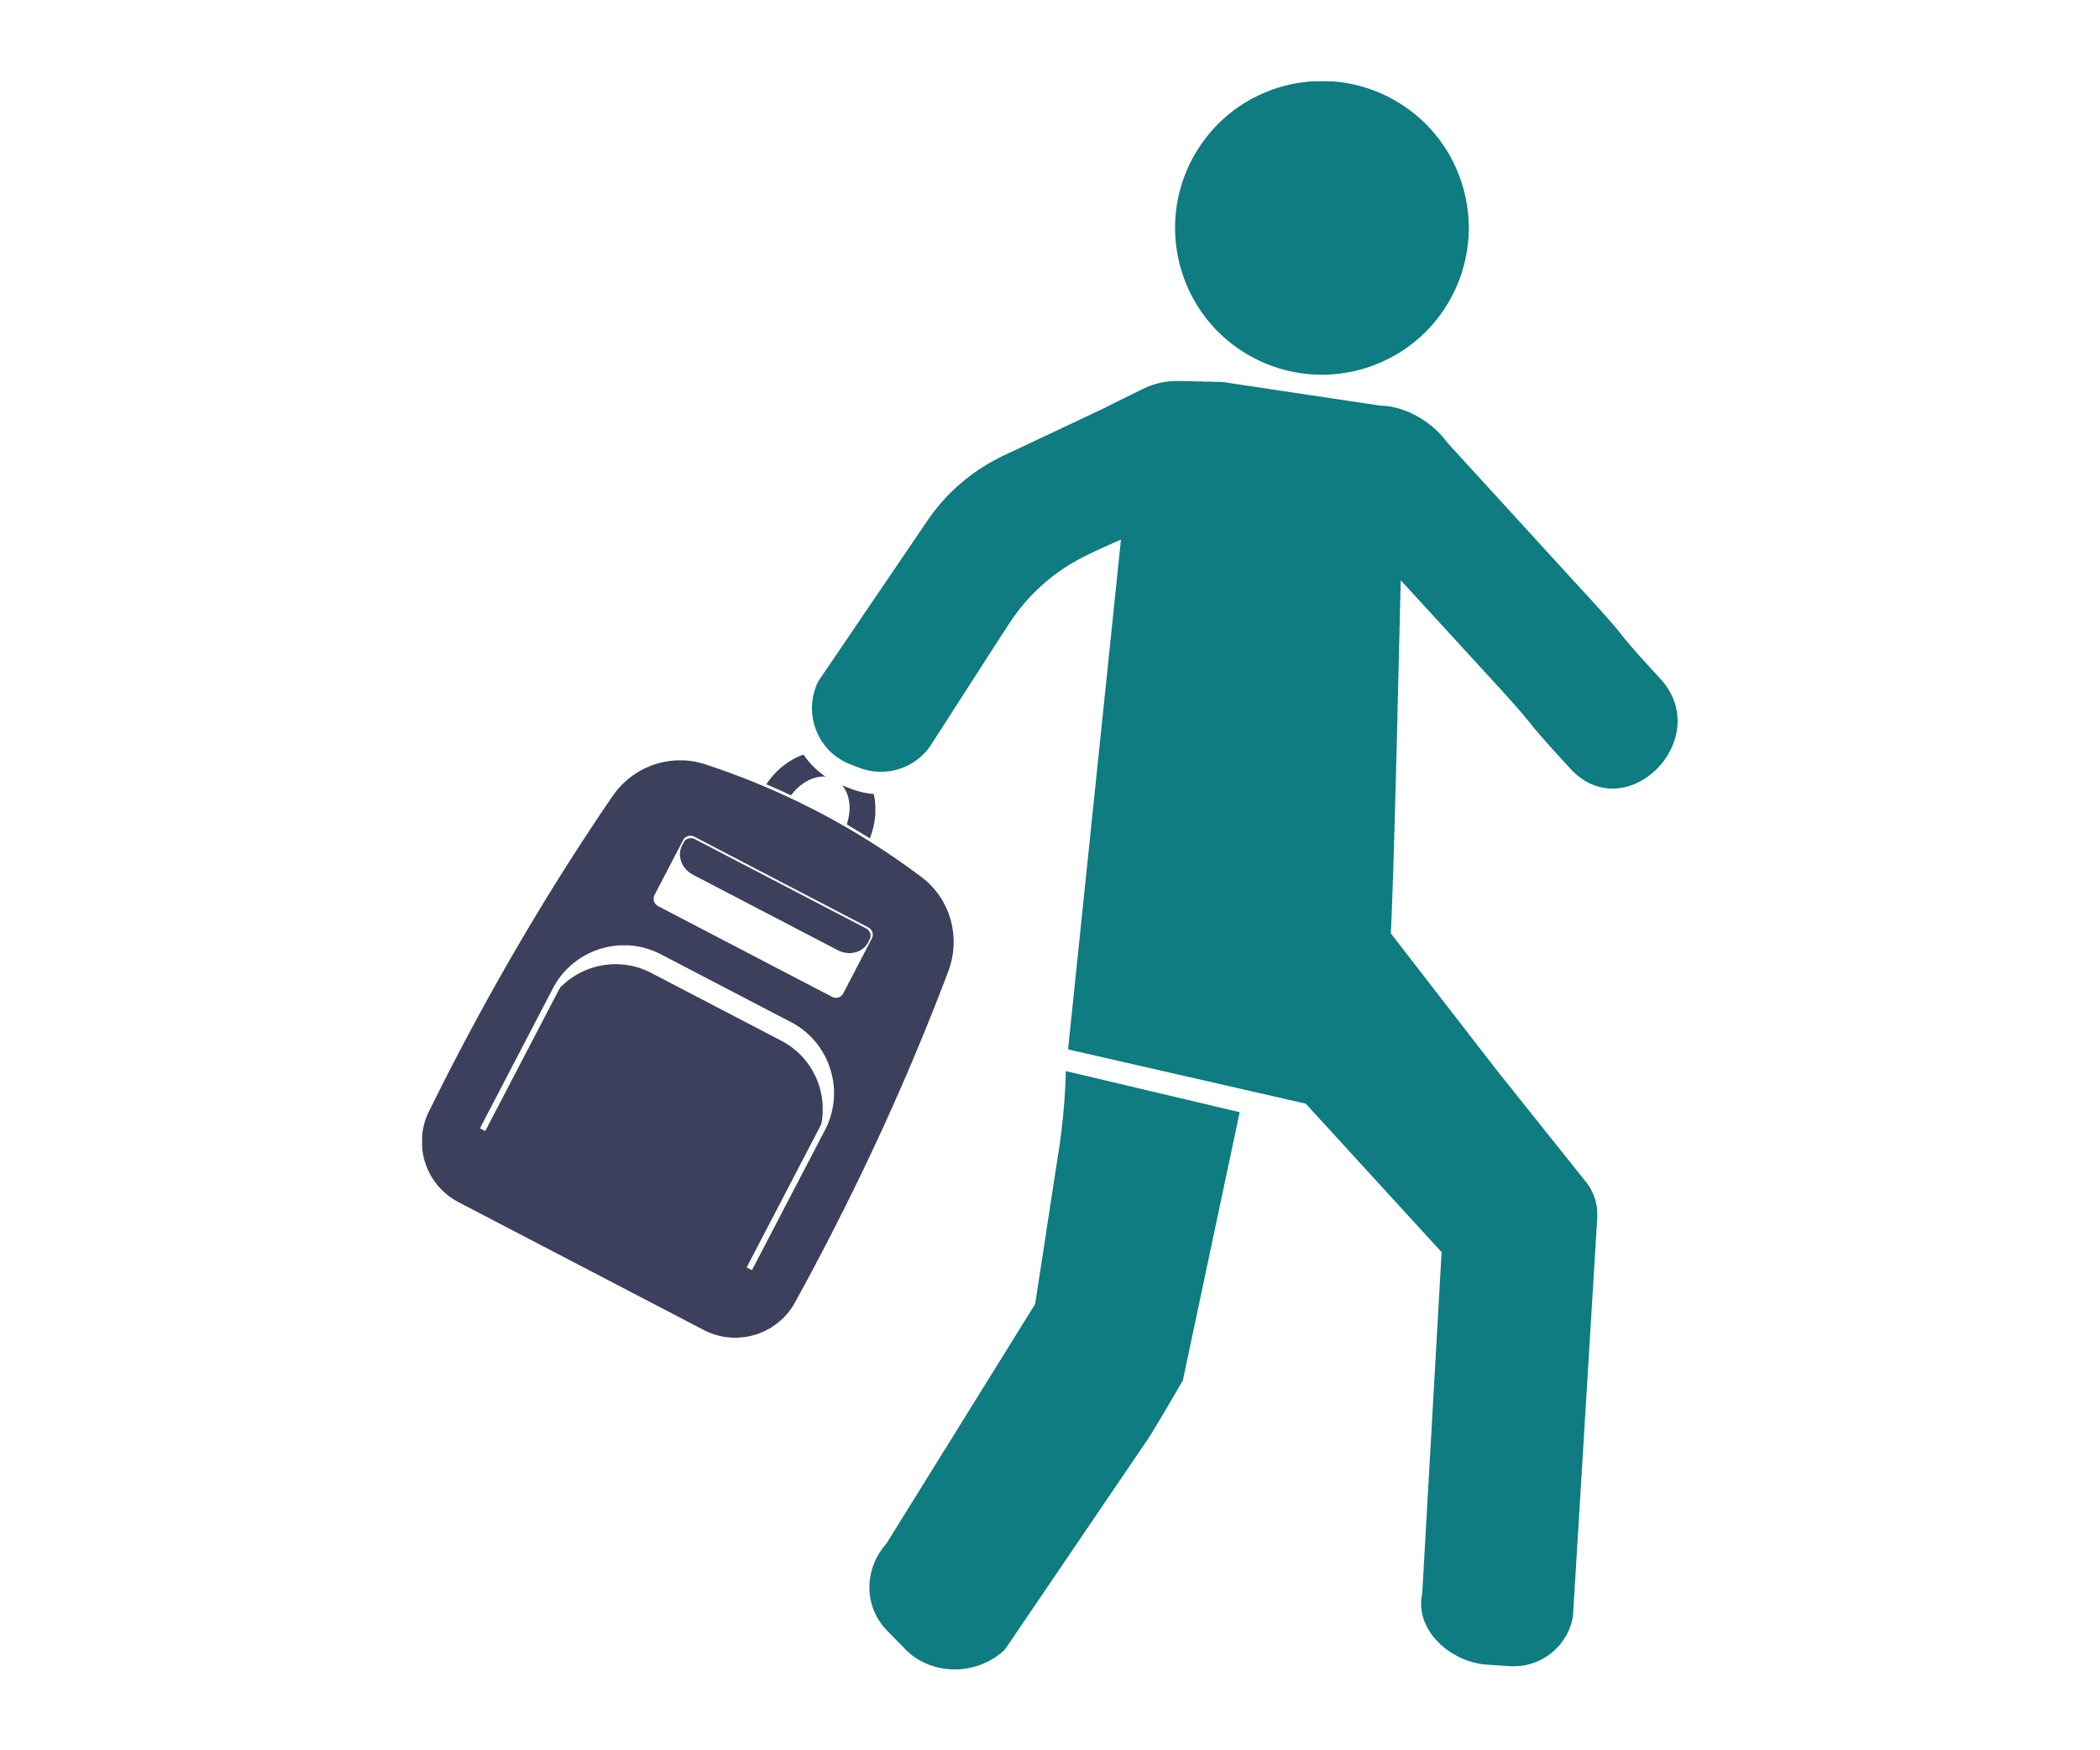
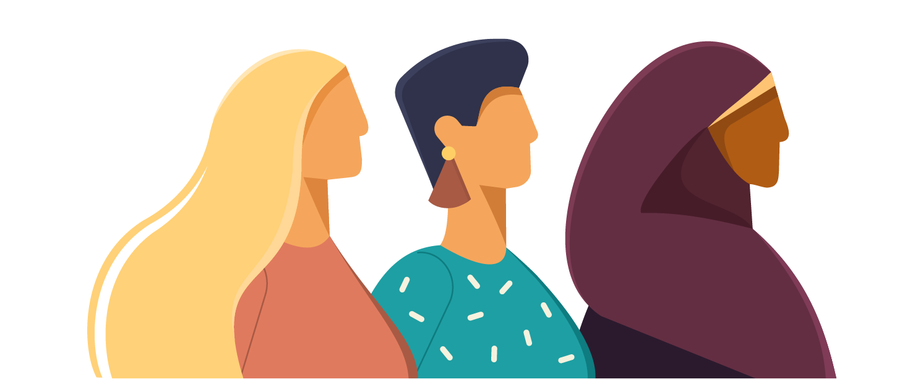
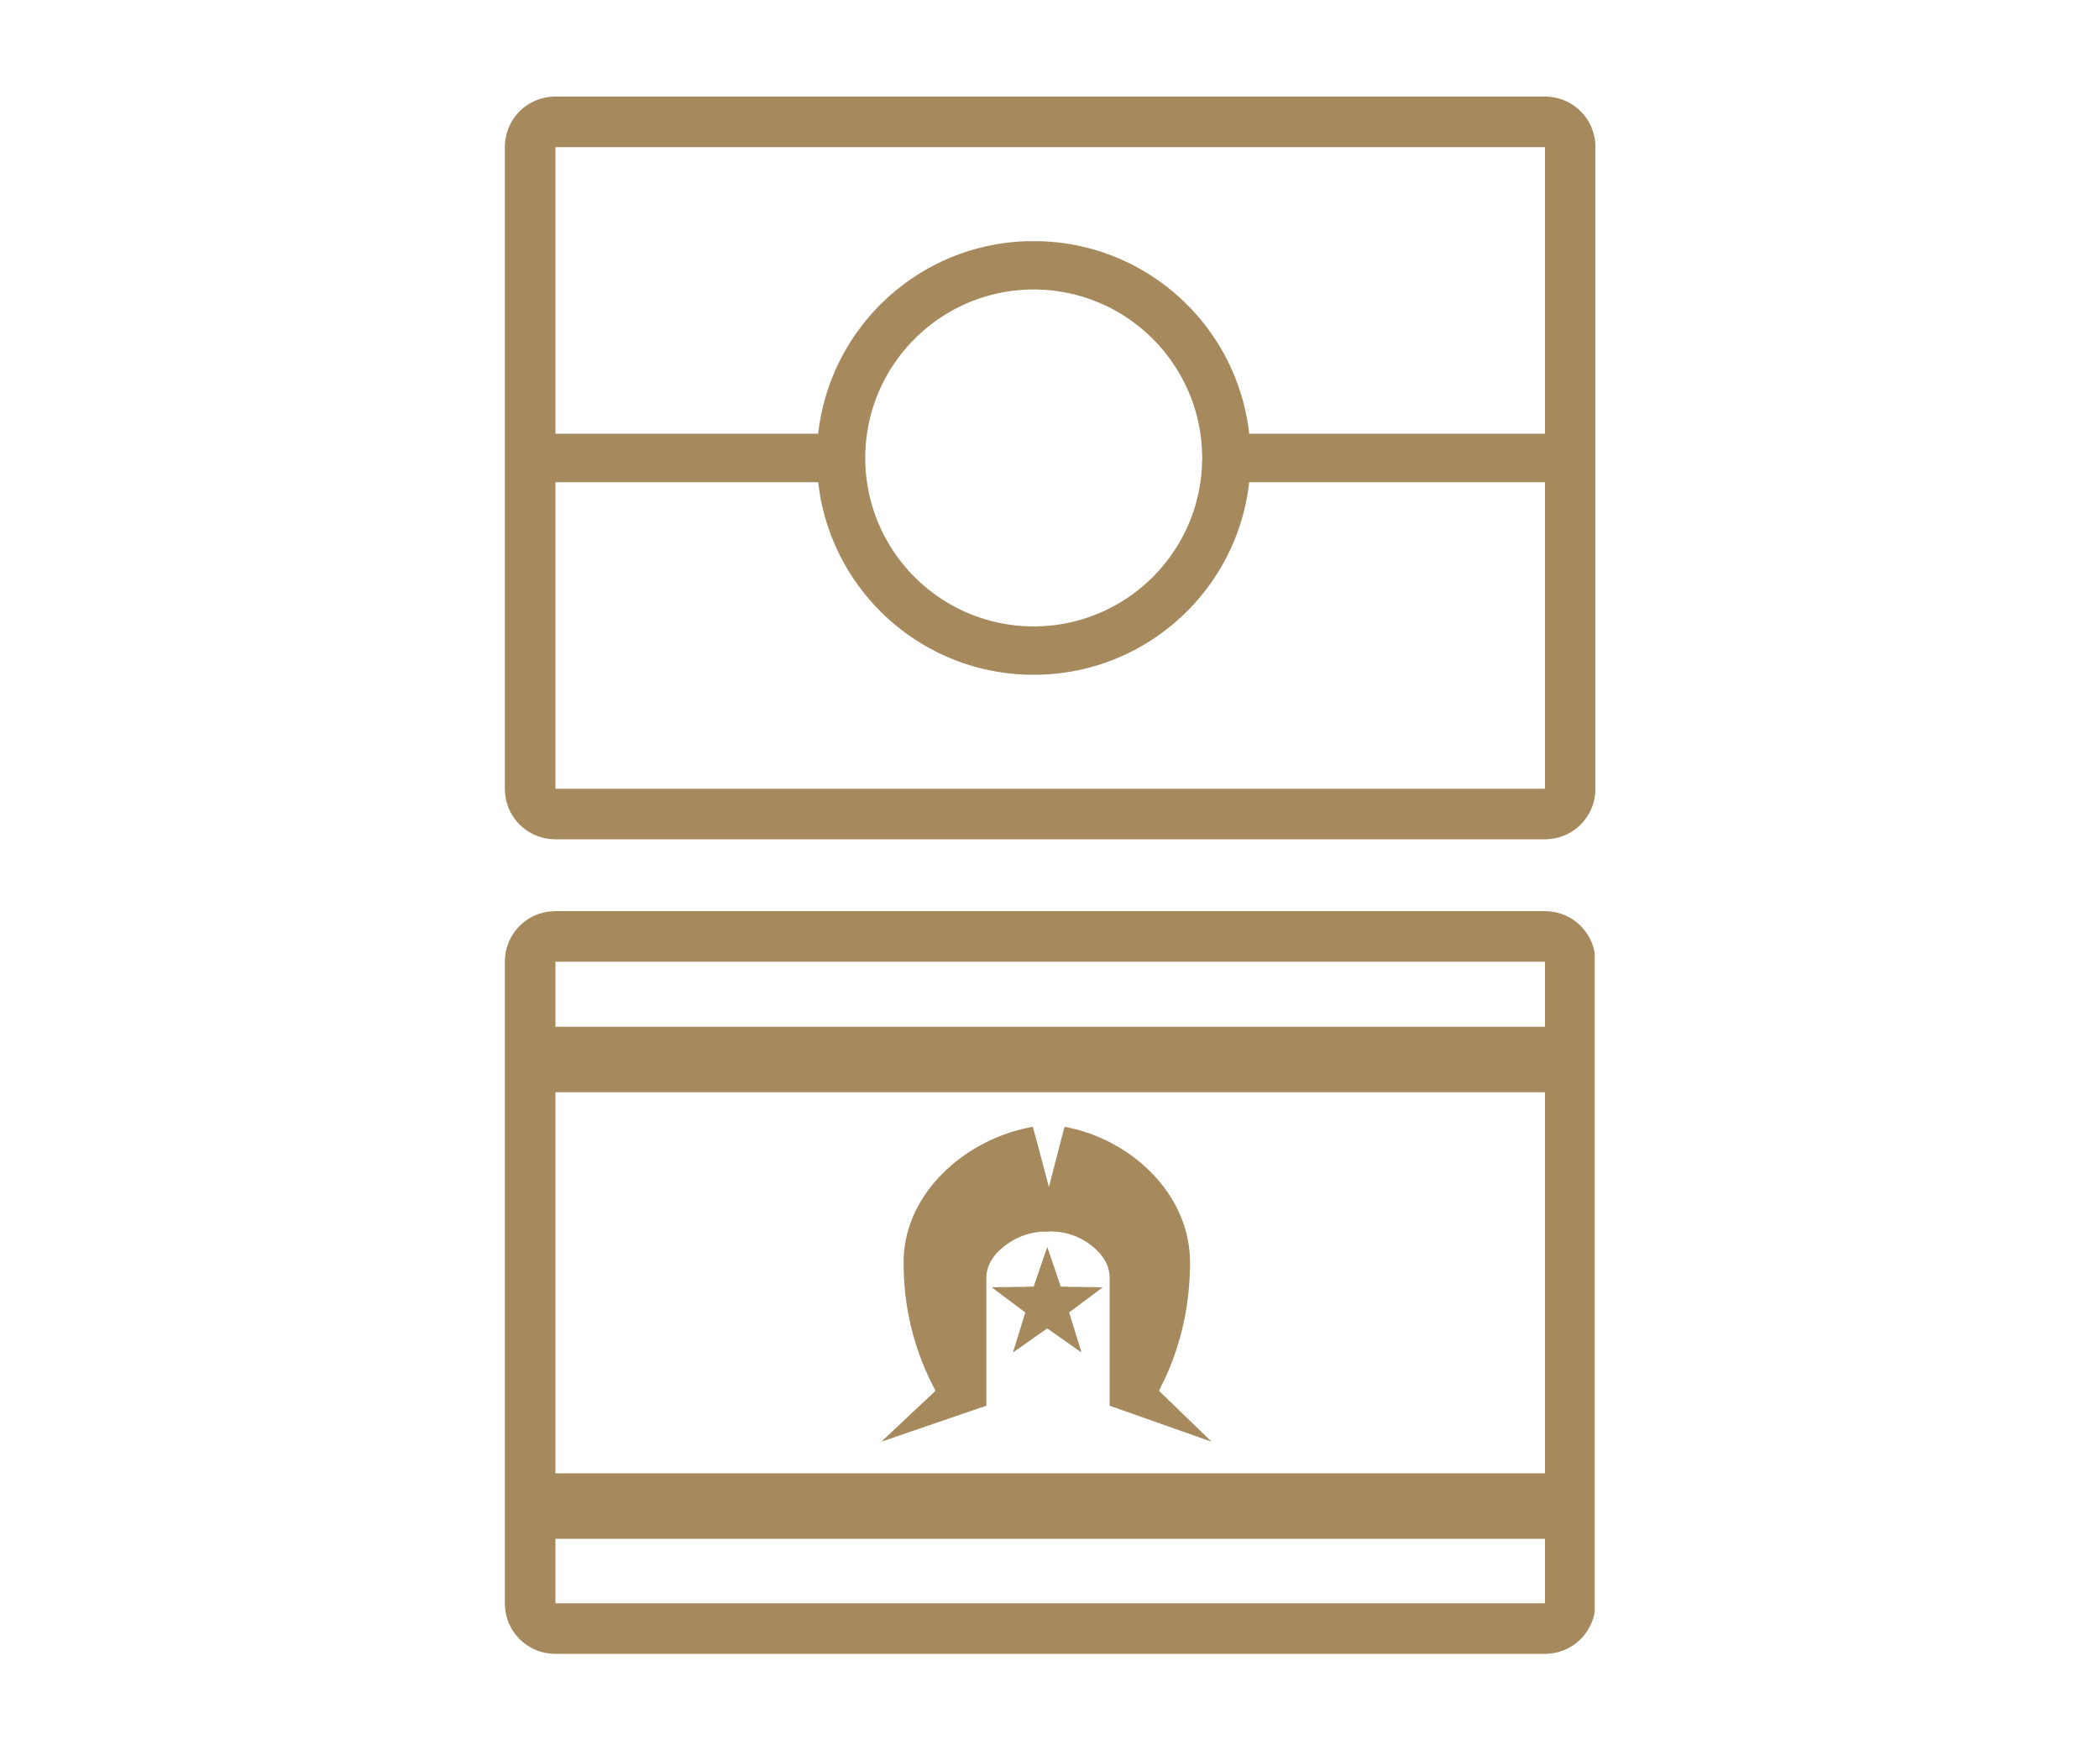
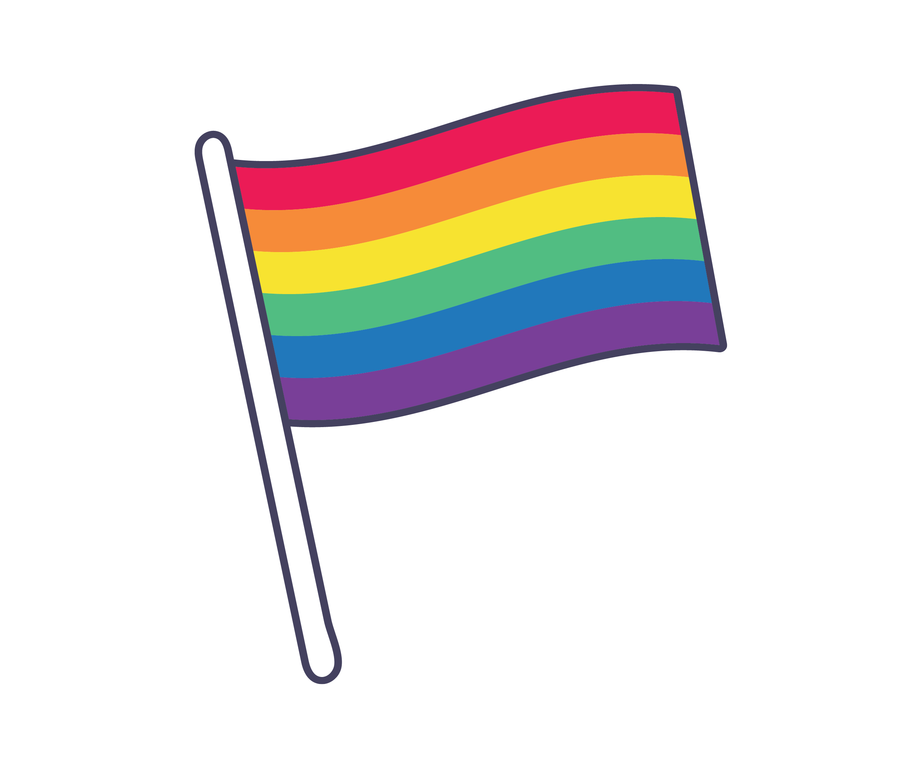
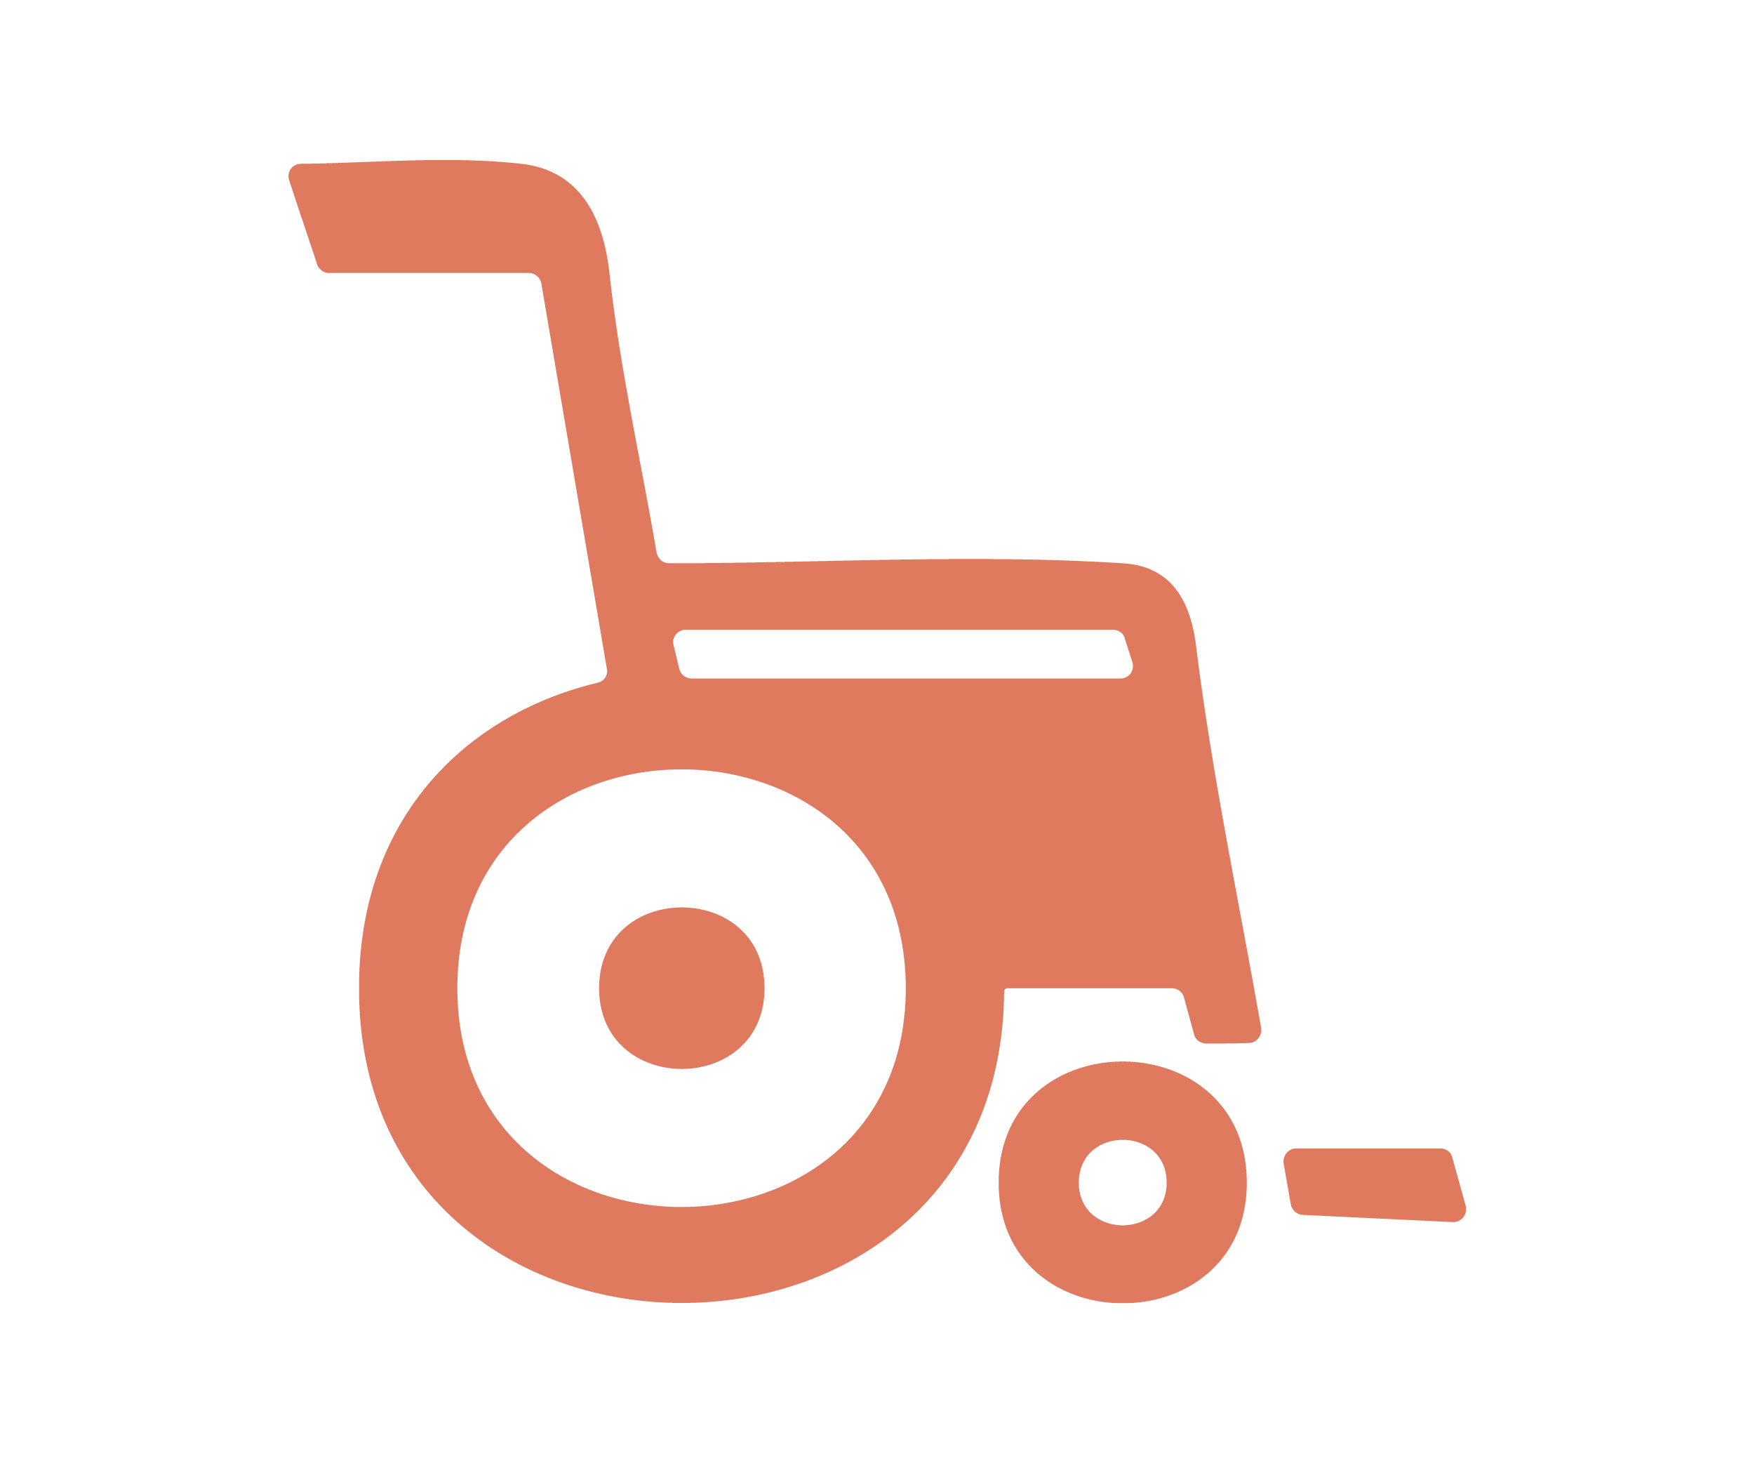
Individuals who are perceived as less powerful based on factors such as race, disability, sexual orientation, or personal circumstances such as economic vulnerability, are more likely to be the target of sexual harassment.

The proportion of people who reported experiencing workplace sexual harassment in the previous five years:
- 39% of female workers
- 26% of male workers
- 45% of young workers aged 18-29
- 53% of Aboriginal and Torres Strait Islander workers
- 44% of workers with disability
- 52% of workers who identify as gay, lesbian, bisexual, pansexual, queer, asexual, aromantic, undecided, not sure, questioning or other
- 77% of workers with an intersex variation.
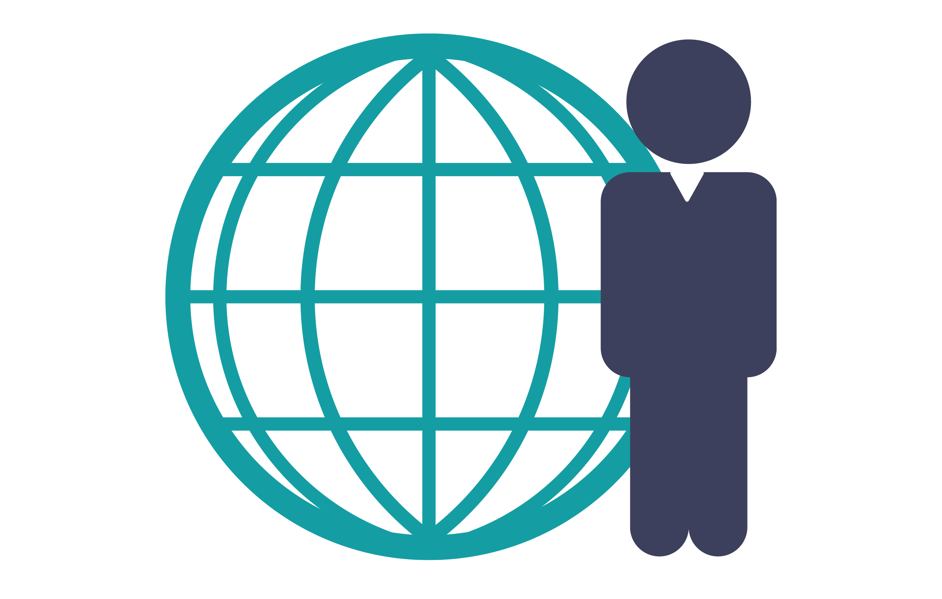
Migrants, refugees and other workers on temporary visas more often work in ‘precarious’ or ‘insecure’ employment that places them at greater risk of harm in the workplace.

Sexual harassment is not random, it is the result of complex and intersecting power imbalances, and the misuse of power. Power imbalances help us to understand why some people harass while others don’t and why harassers target some people and not others.

Workplace contexts and factors that increase risk
Research also shows that sexual harassment is more common in workplaces with particular characteristics. These characteristics intersect with workplace power imbalances and can amplify people’s experiences of workplace sexual harassment.
Workplace settings and industries that have a higher risk of sexual harassment include:
- male-dominated industries
- workplaces with a masculine culture
- workplaces with a high-level of contact with third parties, including customers, clients or patients
- workplaces that are isolated or remote
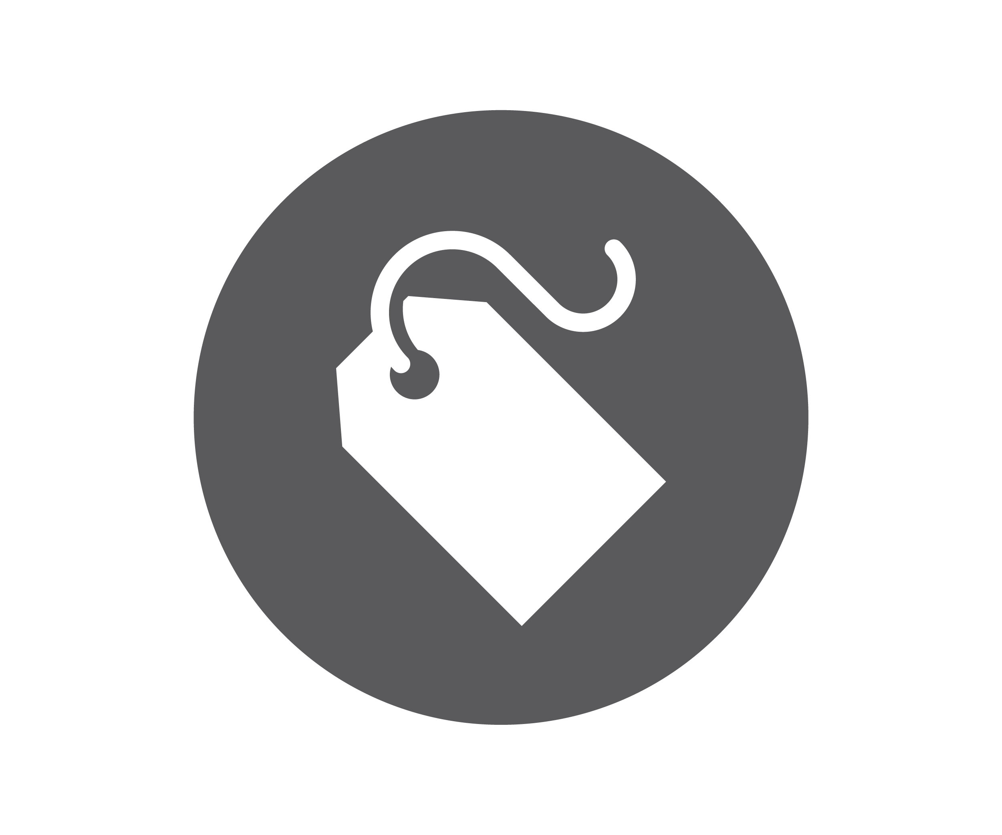
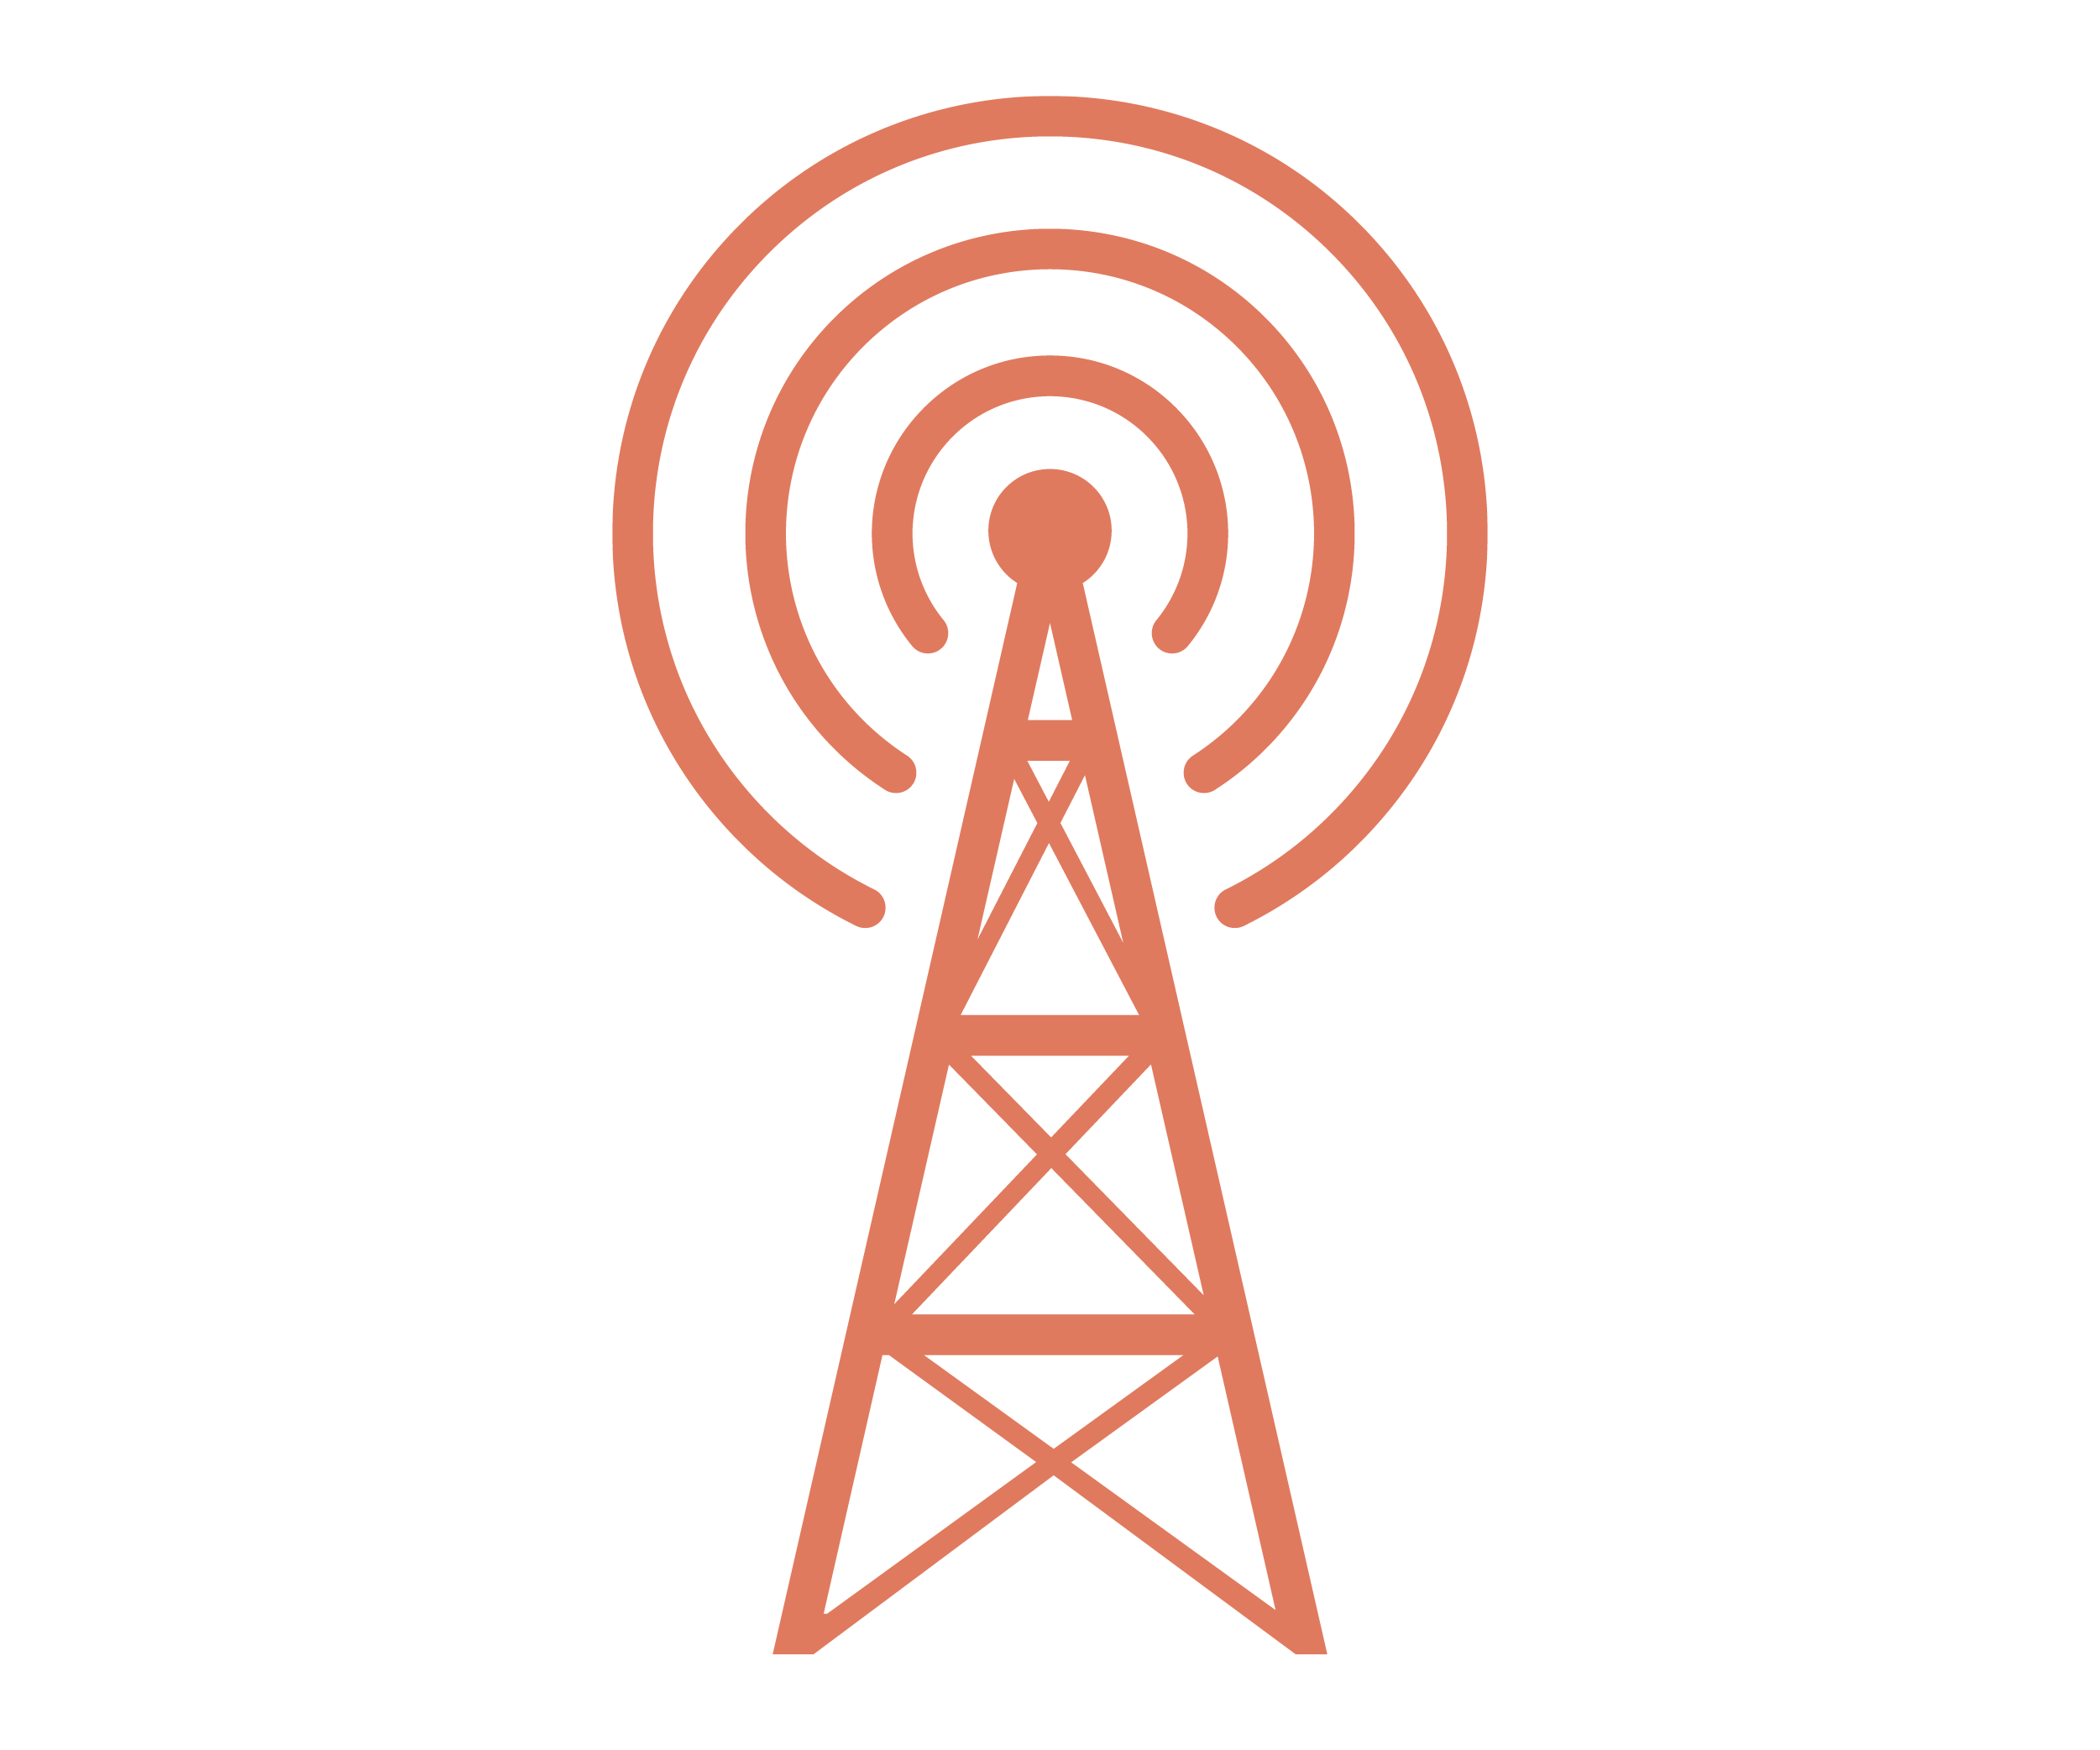
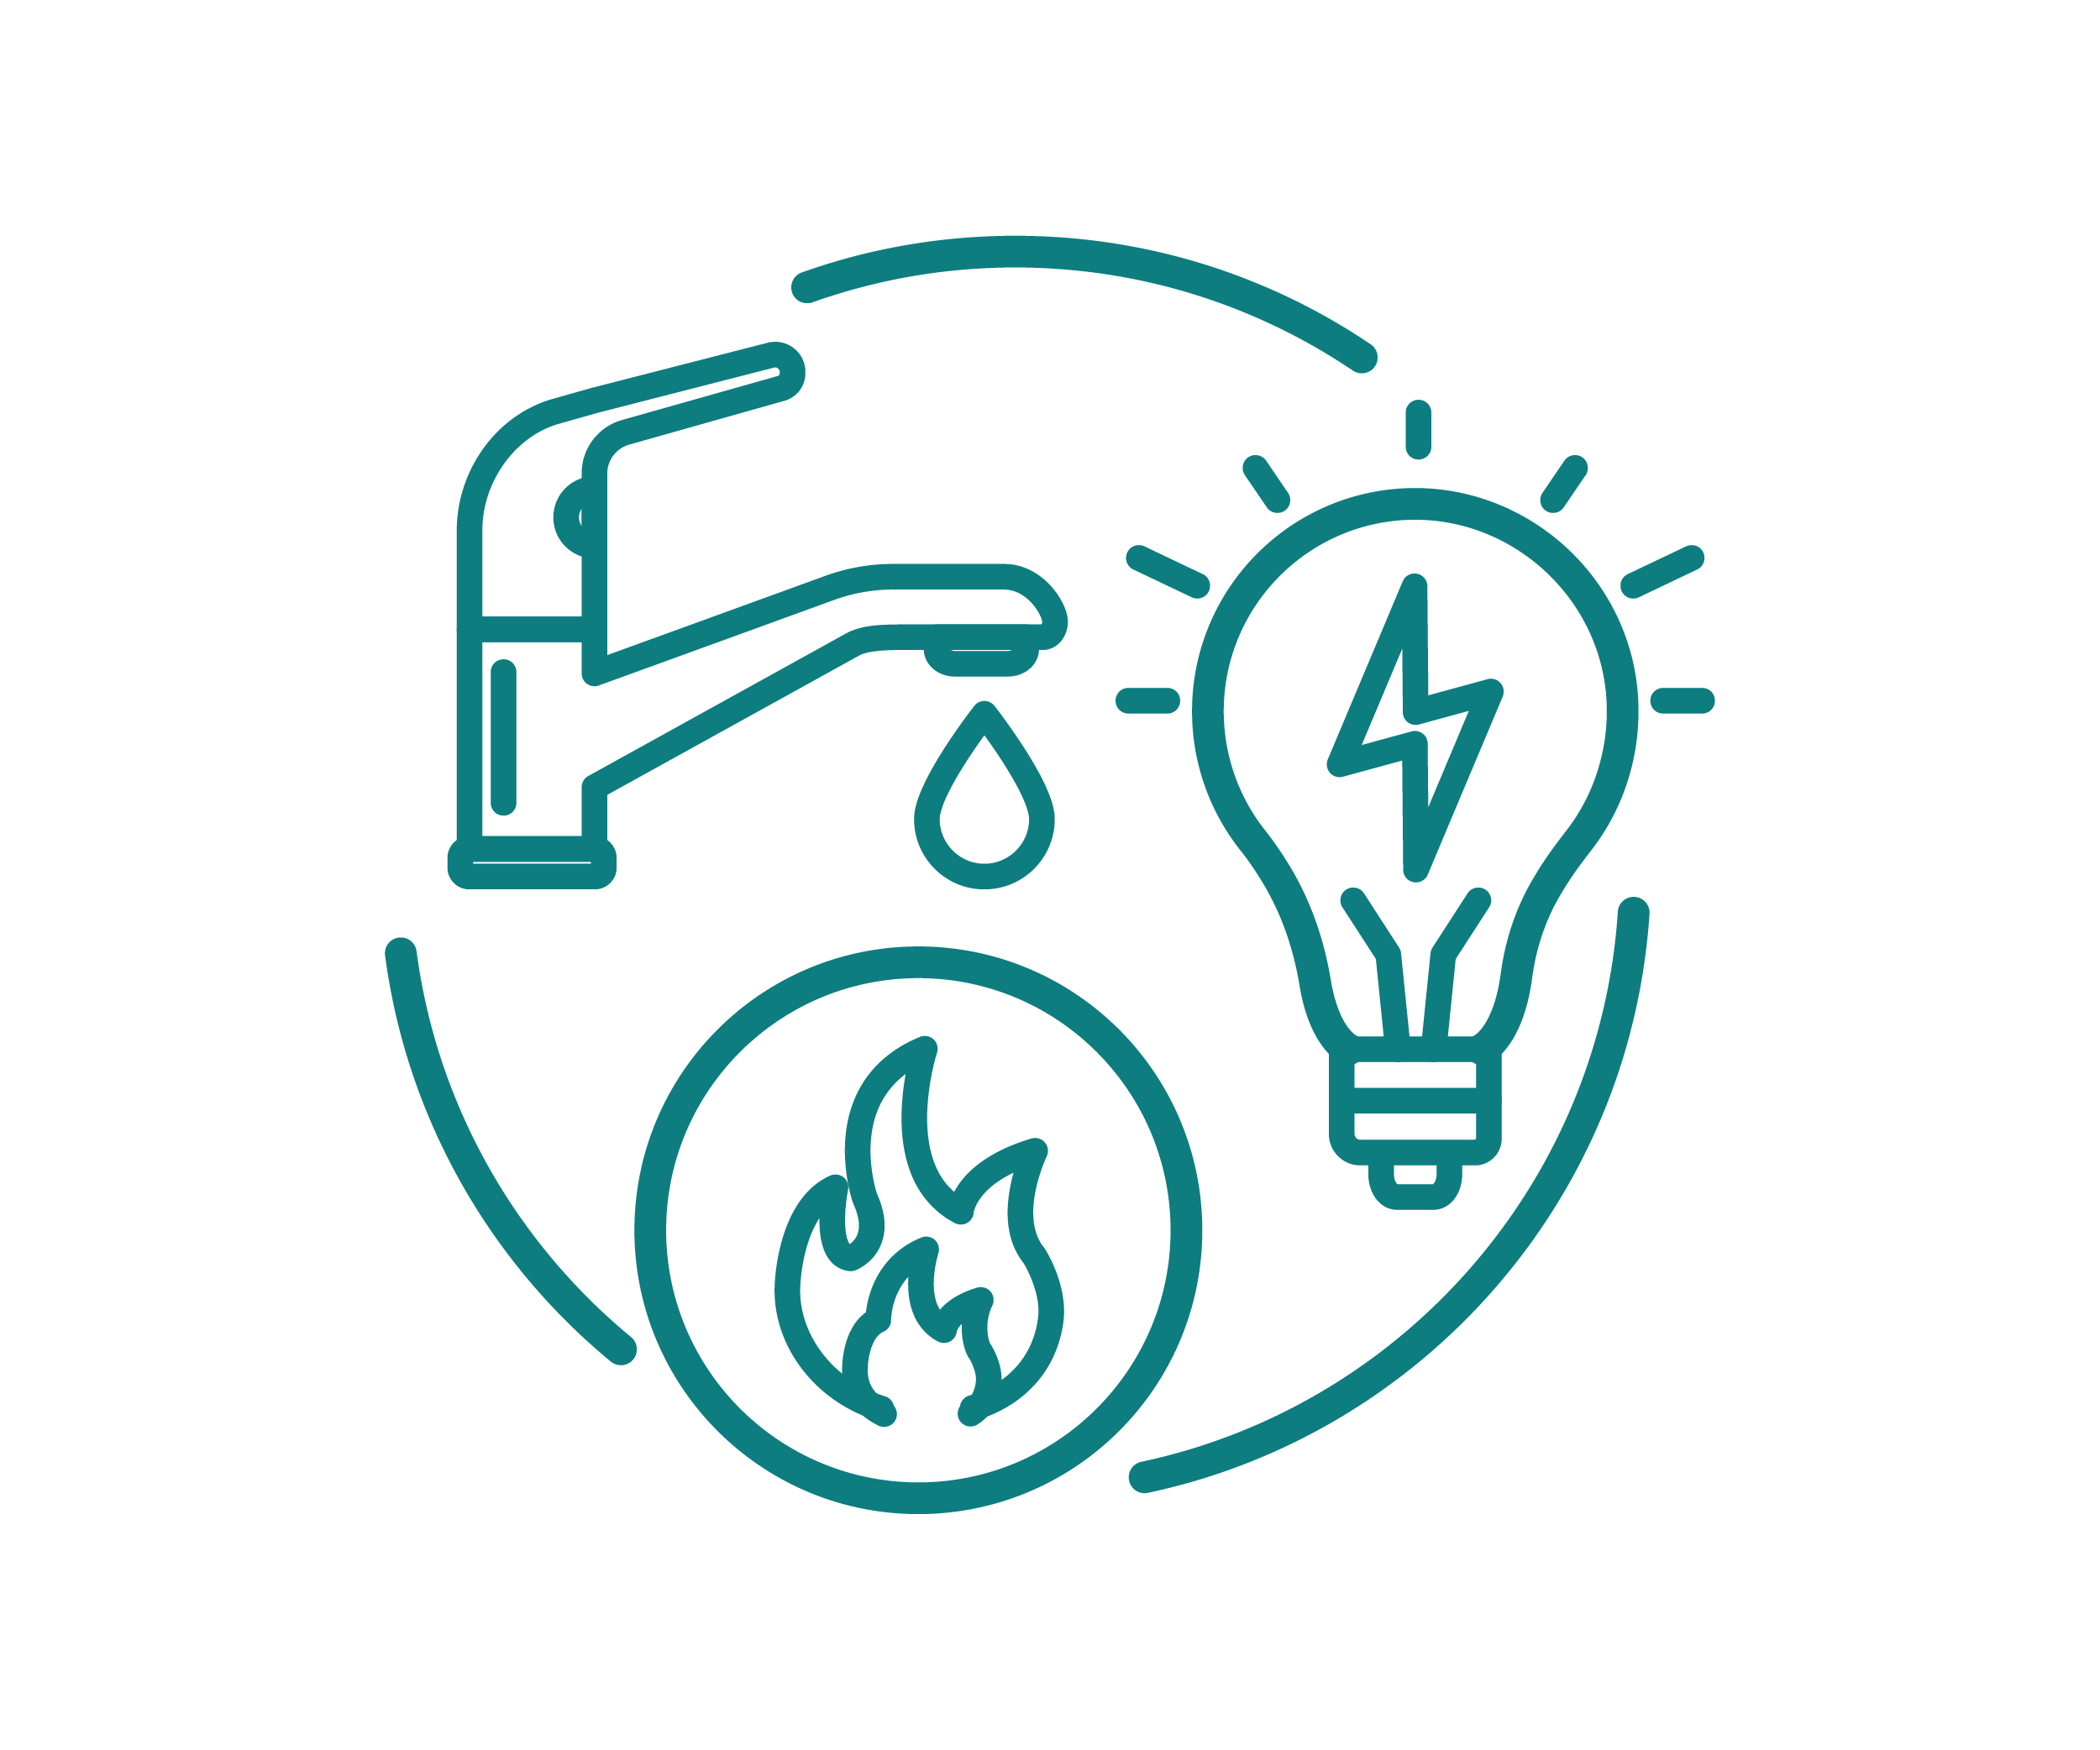
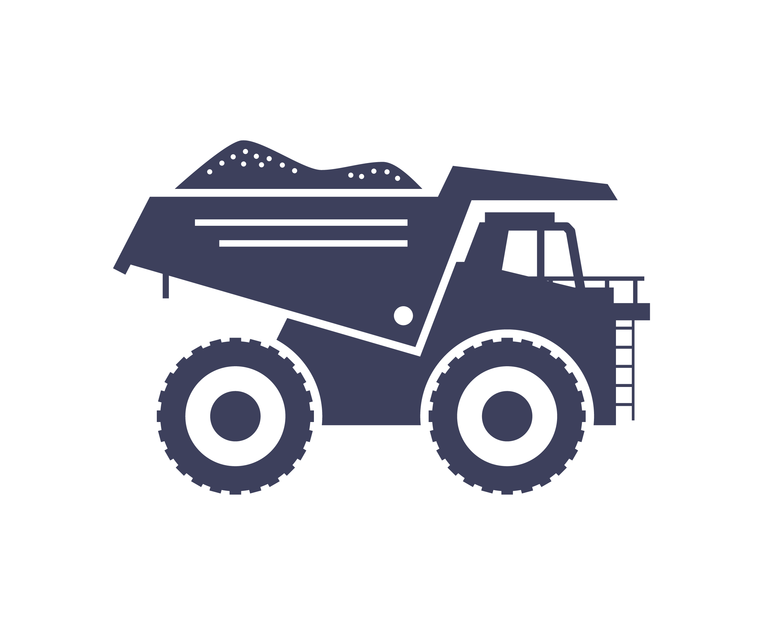
- workplaces that are organised according to a hierarchical structure.
- Some contextual factors that are known to increase risk of sexual harassment include:
- poor workplace culture
- limited understanding of sexual harassment
- misuse of alcohol
- lack of accountability
- lack of diversity.
In order to prevent workplace sexual harassment, we must reduce gender inequality and other forms of discrimination and disadvantage and manage or eliminate the contextual factors known to increase the risk of it occurring.
For more information:
The Respect@Work website provides free information about workplace sexual harassment. To find out more, visit respectatwork.gov.au
f5f2de

References

Paula A Johnson, Sheila E Widnall, and Frazier F Benya (eds), Sexual Harassment of Women: Climate, Culture, and Consequences in Academic Sciences, Engineering, and Medicine (Committee on the Impacts of Sexual Harassment in Academia and Committee on Women in Science, Engineering, and Medicine, Policy and Global Affairs, The National Academies of Sciences, Engineering, and Medicine, 2018) 26–7; Louise F Fitzgerald and Lilia M Cortina, ‘Sexual Harassment in Work Organizations: A View From the 21st Century’ in Cheryl B Travis and Jacquelyn W White (eds), APA Handbook of the Psychology of Women, Volume 2: Perspectives on Women’s Private and Public Lives (APA Handbooks in Psychology Series, 2018) 215, 216. See also Craig Waldo, Jennifer Berdahl and Louise Fitzgerald, ‘Are Men Sexually Harassed? If So, by Whom?’ (1998) 22(1) Law and Human Behaviour 59.
Our Watch, ‘Build new social norms not constrained by rigid gender stereotypes’, viewed 16.02.2022.
Australian Bureau of Statistics, 2071.0 - Census of Population and Housing: Reflecting Australia – Stories from the Census, 2016, Snapshot of Australia (June, 2017).
Australian Bureau of Statistics, 6202.0 - Labour Force, Australia, Table 01: Labour force status by sex (December 2017).
Australian Bureau of Statistics (2021), Labour Force, Australia, July 2021, cat. no. 6291.0.55.003, viewed 19.08.2021.
Australian Bureau of Statistics (2021), Labour Force, Australia, July 2021, cat. no. 6291.0.55.003, viewed 19.08.2021.
Workplace Gender Equality Agency, Australia’s gender pay gap statistics, viewed 31.03.2022.
Workplace Gender Equality Agency, ‘Women in leadership’, viewed 31.03.2022
Australian Bureau of Statistics (2018), Labour Force, Australia, Detailed, quarterly, May 2018, cat. no. 6202.0, viewed 19.08.2021.
Parliament of Australia, Parliamentary Library, ‘Gender composition of Australian parliaments by party: a quick guide’, Research paper series 2022-23, viewed 04.09.22.
See Francisco Perales, Christine Ablaza, Wojtek Tomaszewski & Dawn Emsen-Hough, ‘You, me, Them: Understanding Employees’ Use of Trans-Affirming Language within the Workplace’, Sexuality Research and Social Policy (2021); See also Jacqueline Ullman, ‘Present, yet not welcomed: gender diverse teachers’ experiences of discrimination’, (2020) Teaching Education, 31:1, 67-83, DOI: 10.1080/10476210.2019.1708315.
M.V. Lee Badgett, Holning Lau, Brad Sears, Deborah Ho, ‘Bias in the Workplace: Consistent evidence of sexual orientation and gender identity discrimination’, (2007) Viewed 28.03.22
Australian Human Rights Commission, Fourth National Survey on Sexual Harassment in Australian Workplaces (2018).

