## 

## In this document:

1. The definition of sexual harassment
2. The definition of workplace sexual harassment
3. The causes of workplace sexual harassment
4. Your rights under the law
5. Workplace responsibilities
6. What to do if you are sexually harassed at work
7. Getting help
8. Reporting workplace sexual harassment

This resource includes information for younger workers about workplace sexual harassment and how you can respond to it if it happens to you or a friend or co-worker. Remember: **if you, or someone else, is in immediate danger you should call the police on 000. If there is no immediate danger but you or someone else needs police assistance, phone 131 444.**

Workplace sexual harassment is against the law.

# The definition of sexual harassment

In simple terms, sexual harassment means any unwelcome sexual behaviour that a reasonable person could anticipate may make another person feel offended, humiliated or intimidated in that situation.

A **‘reasonable person’** can be taken to mean a neutral and unbiased observer.

Sexual harassment is not always obvious. It includes a wide range of behaviours. The most common behaviours are:

* sexually suggestive comments or jokes that offend or intimidate
* intrusive questions about private life or physical appearance
* inappropriate staring or leering
* inappropriate physical contact
* unwelcome touching, hugging, cornering or kissing.

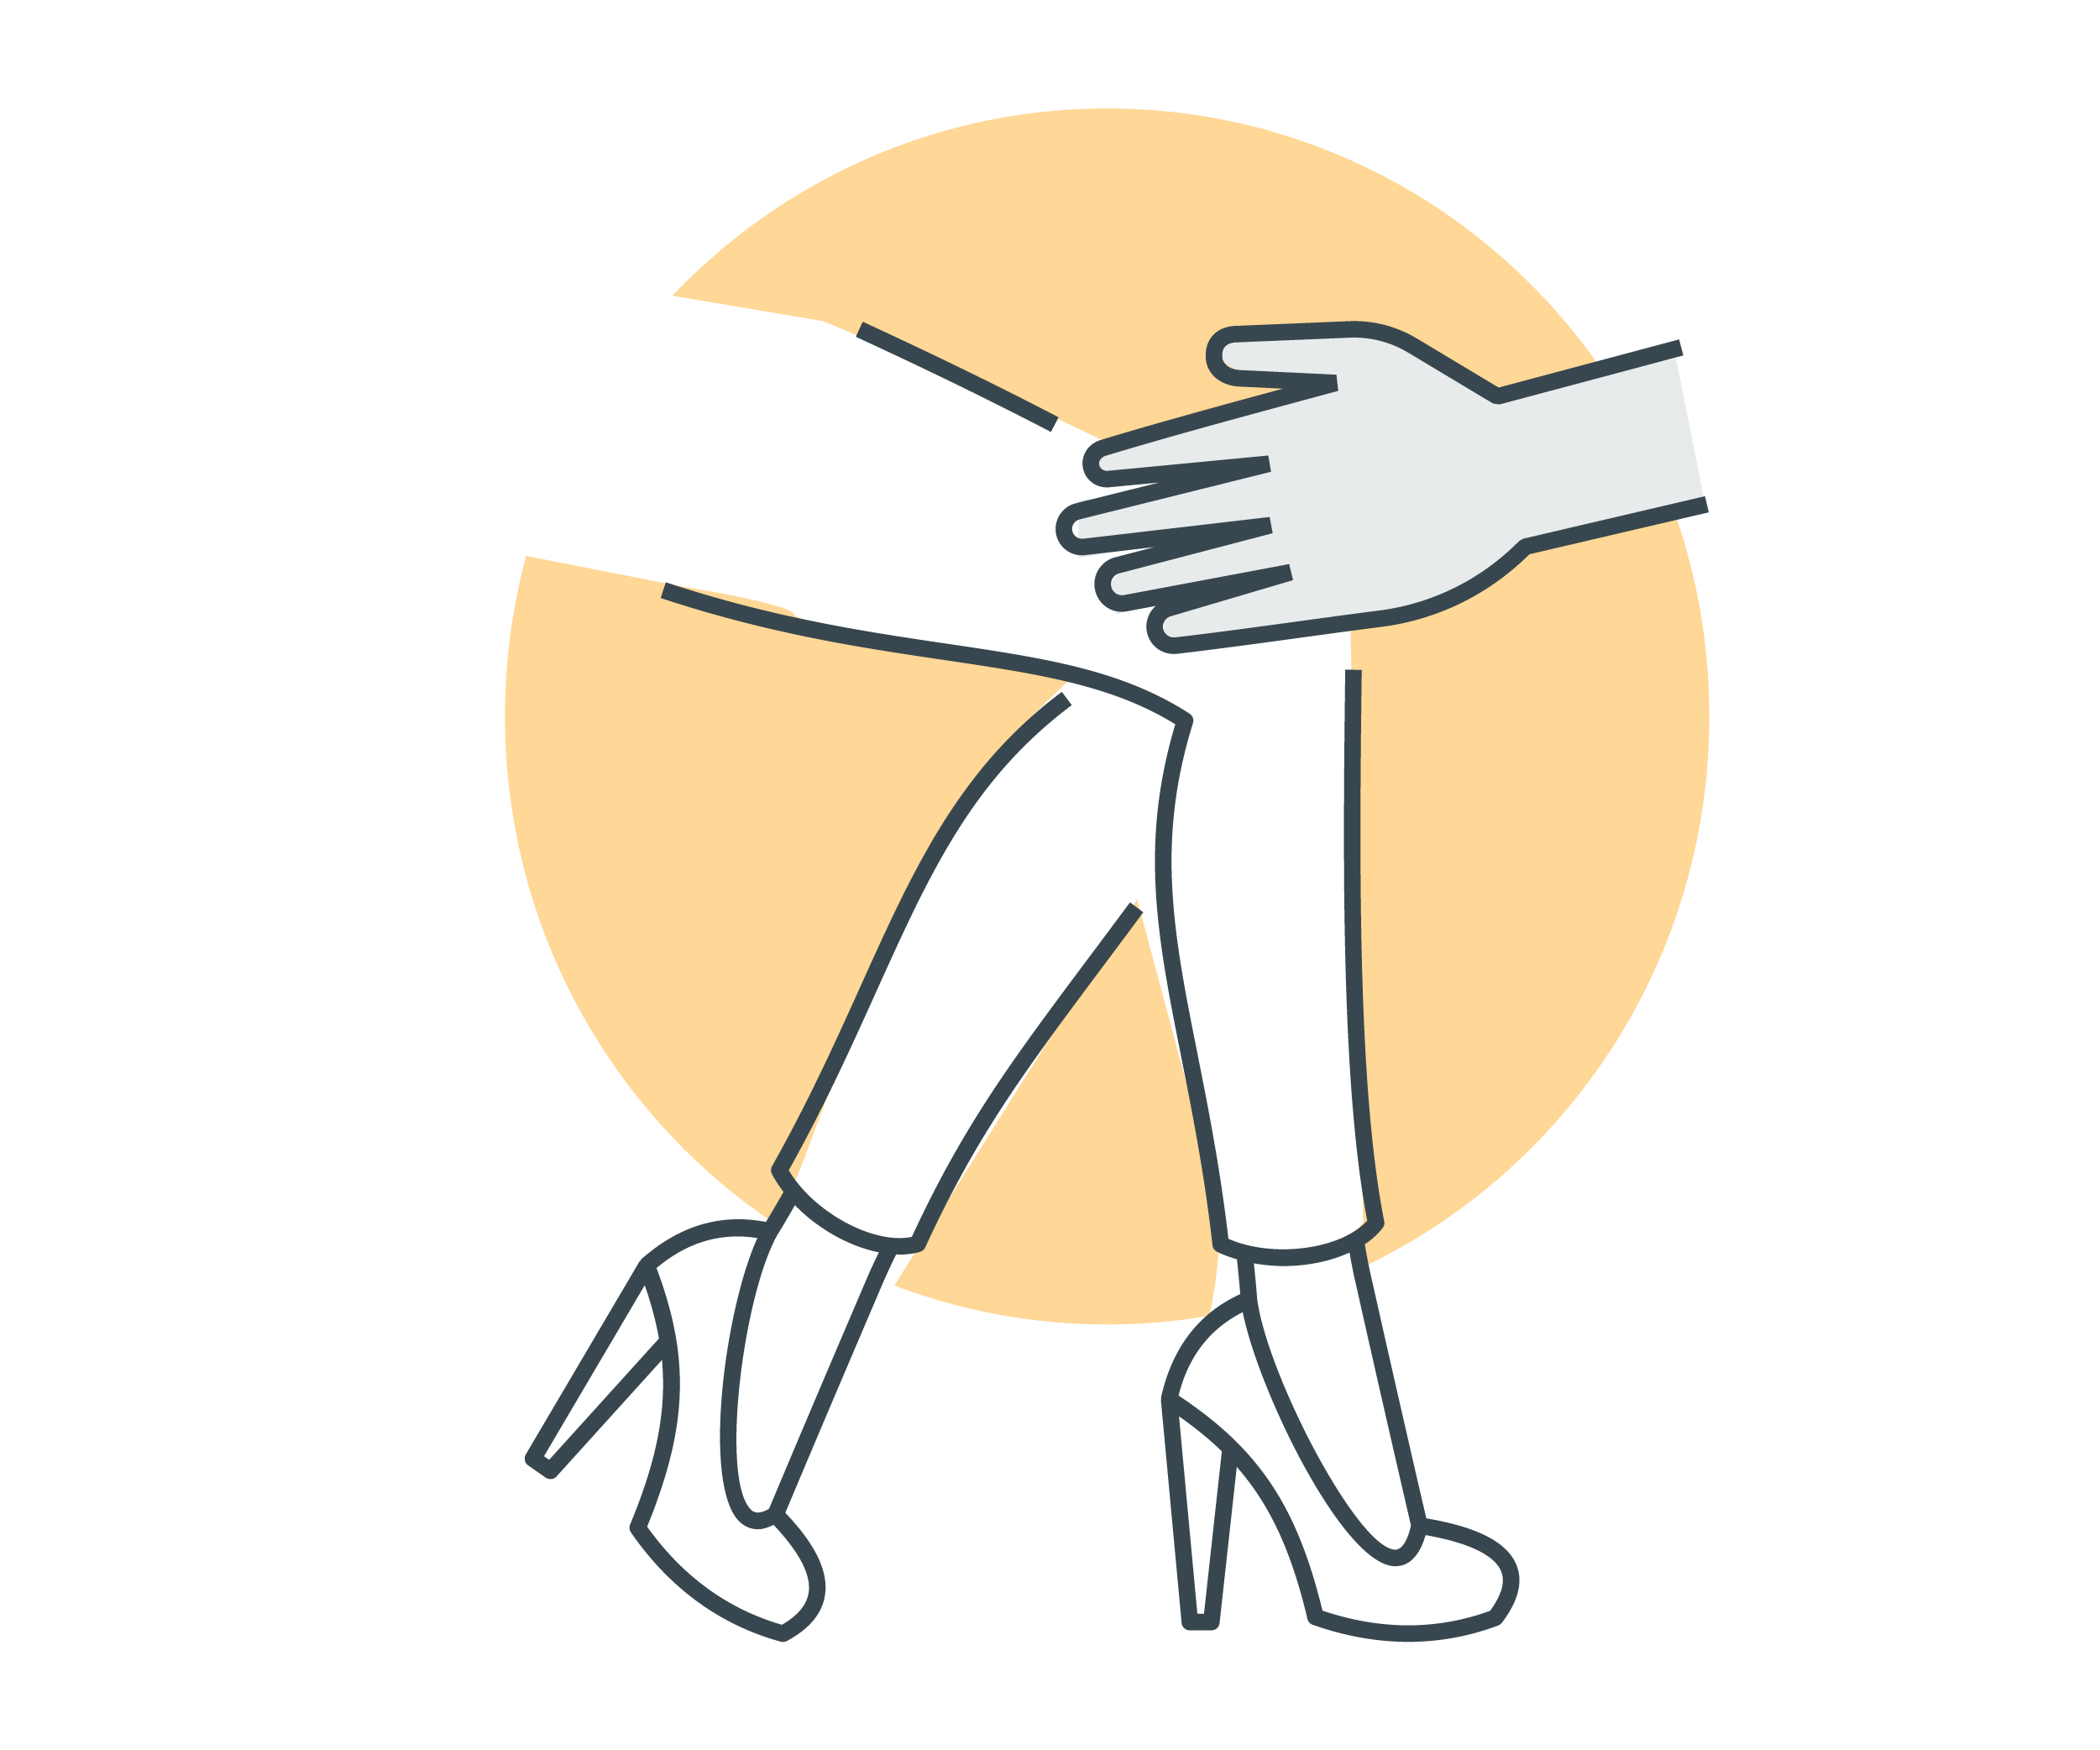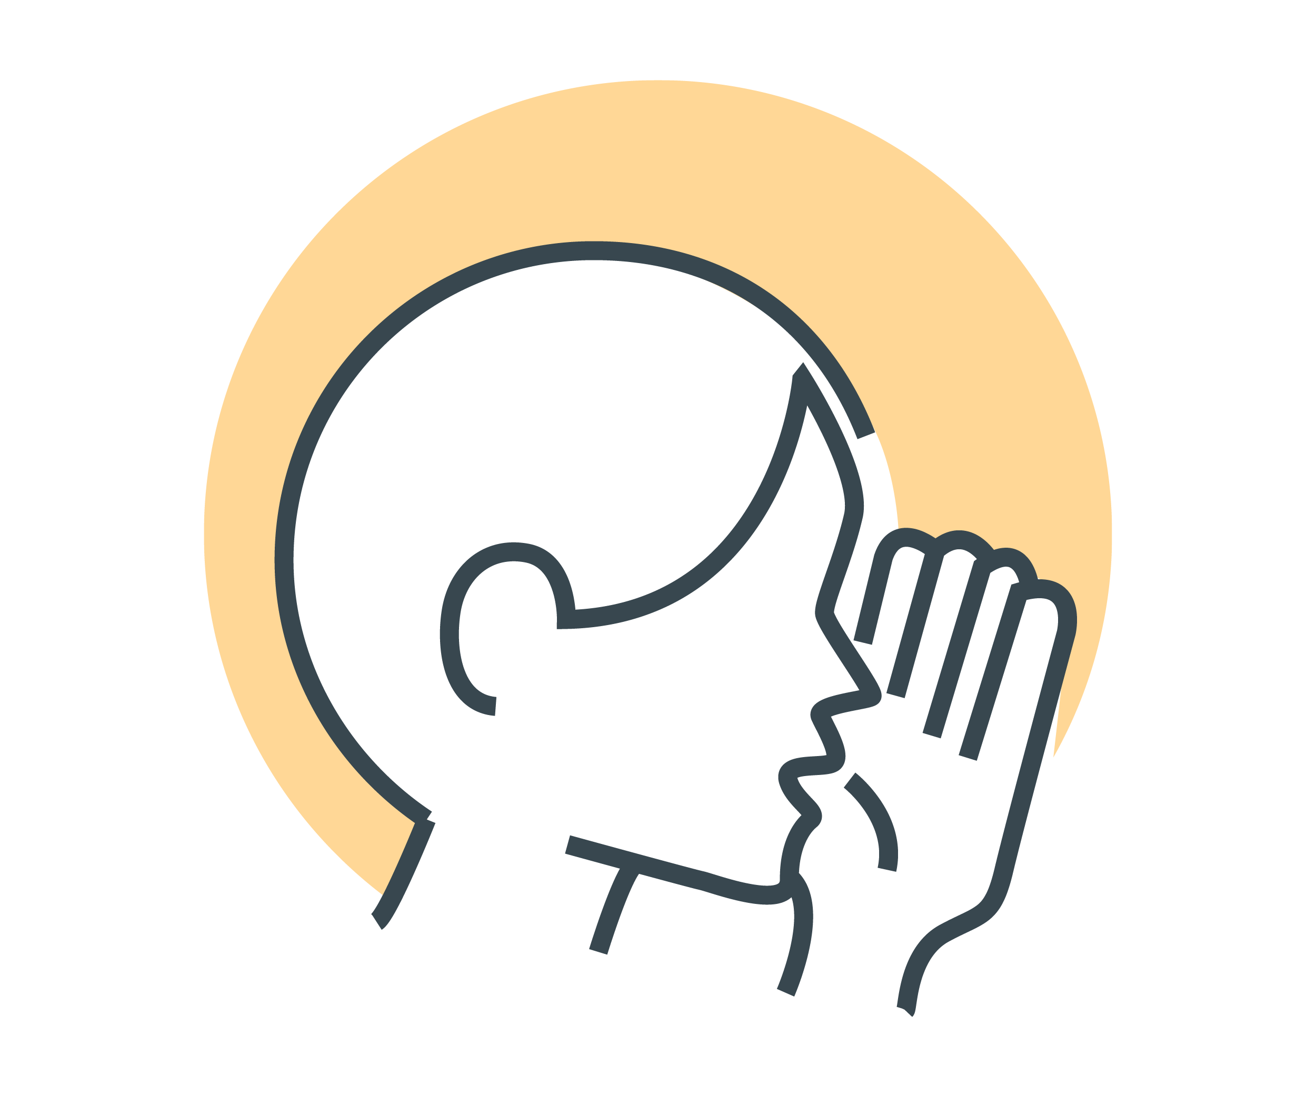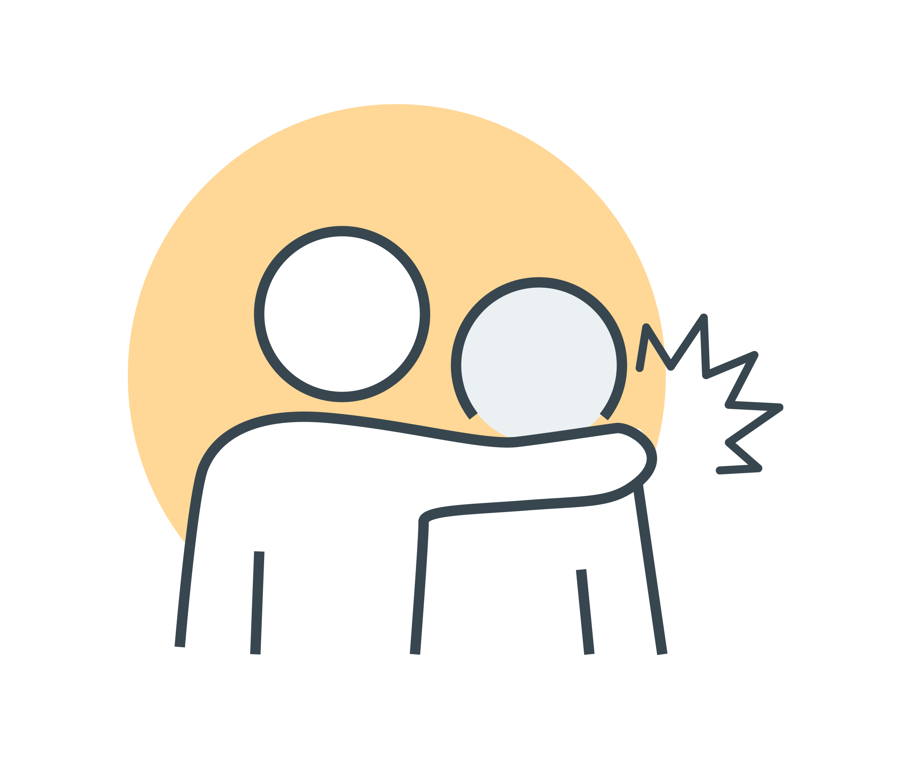

Other examples of sexual harassment include:

* sharing or threatening to share intimate images or video without consent
* images or videos that are sexually suggestive or that constitute a sexual advance
* repeated or inappropriate invitations to go out on dates
* requests or pressure for sex or other sexual acts
* sexually explicit gifts, images, videos, cartoons, drawings, photographs, or jokes
* actual or attempted rape or sexual assault
* being followed or watched inappropriately, or someone loitering inappropriately, either in person or via technology
* sexually explicit comments made in person or in writing, or indecent messages (SMS, social media), phone calls or emails—including the use of emojis with sexual connotations
* sexual gestures, indecent exposure or inappropriate display of the body
* technology-facilitated unwelcome conduct of a sexual nature—including on virtual meetings
* repeated or inappropriate advances on email or other online social technologies.

**Sexual harassment happens in person, over the phone and online, including via social media.**



# The definition of workplace sexual harassment

If sexual harassment occurs at, or in connection with, work then it is against the law.

Sexual harassment is against the law if it happens:

* between individuals who have a particular workplace relationship, or
* during work, or in connection with work.

A ‘**worker’** is anyone who carries out work for an employer or business. This includes full-time, part-time and casual workers, workers on probation, contract-based workers, self-employed workers, interns, apprentices, students and volunteers (unless the organisation is run entirely by volunteers).

### Workplace relationships

Regardless of whether it happens in the workplace, or elsewhere, it is against the law for:

* an employer to sexually harass a worker, or anyone seeking to become a worker
* a worker to sexually harass another worker*, or anyone seeking to become a worker.

* Another worker could be a manager. It could also be a worker who is more senior, less senior, or at the same level as you.

### In connection with the workplace

There are also people other than workers and employers in the workplace (for example, clients, customers and contractors). The law protects you from workplace sexual harassment by these people as well. A workplace includes any place where work is done and includes any place where a worker goes, or is likely to be, while working. This includes:

* your main place of work (for example, a store, office or business)
* common areas (for example lifts, reception areas, corridors, kitchens and bathrooms)
* your home or another location, if you are working remotely
* agency or on-call work (for example, where you travel to different places or other people’s homes to do your work)
* conferences, training and other professional development programs, whether onsite or offsite
* transportation, travel and accommodation, if you are travelling for work
* work social and networking events.

If you are sexually harassed while you are at any of these places in connection with your work, it can still be against the law.

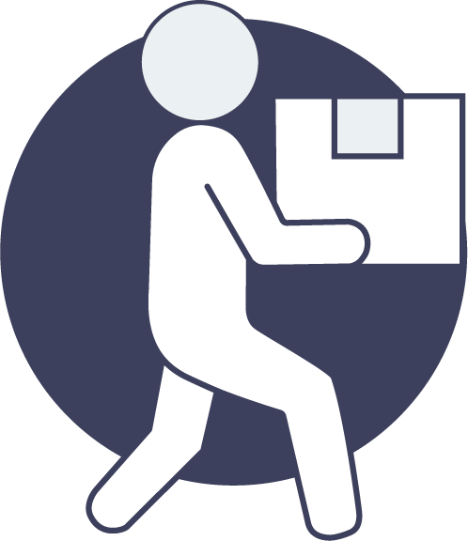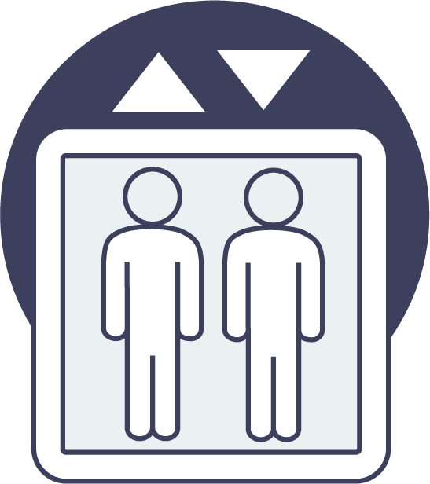

# 

# ""The causes of workplace sexual harassment

In Australia, workplace sexual harassment has been against the law since 1984; but it is still common in workplaces across the country. A 2018 survey found that in the last 5 years, 1 in 3 people had experienced workplace sexual harassment.

If you are sexually harassed it is not your fault.

**Power** relates to the possession of control, authority, or influence over others.

Workplace sexual harassment is primarily caused by imbalances in power between different people in the workplace. These power imbalances stem from many different factors, including:

* personal characteristics such as gender, race, disability and age
* role or position in the workplace
* perceived value to the business
* visa status
* economic vulnerability
* geographic location.

People who are perceived as being less powerful because of these, or other factors, are more likely to be the target of sexual harassment.

In Australian workplaces, the main power imbalance is gender inequality. This explains why women are more likely to be sexually harassed than men.

A 2018 survey found that in the last five years:

* 40% of women (compared to 25% of men)
* 45% of workers aged 18-29 reported being sexually harassed
* 55% of Aboriginal and Torres Strait Islander women and 50% of men
* 44% of people with disability
* 52% of people who identify as gay, lesbian, bisexual, pansexual, queer, asexual, aromantic, undecided, not sure, questioning or other
* 77% of people with an intersex variation

had been sexually harassed in the workplace.

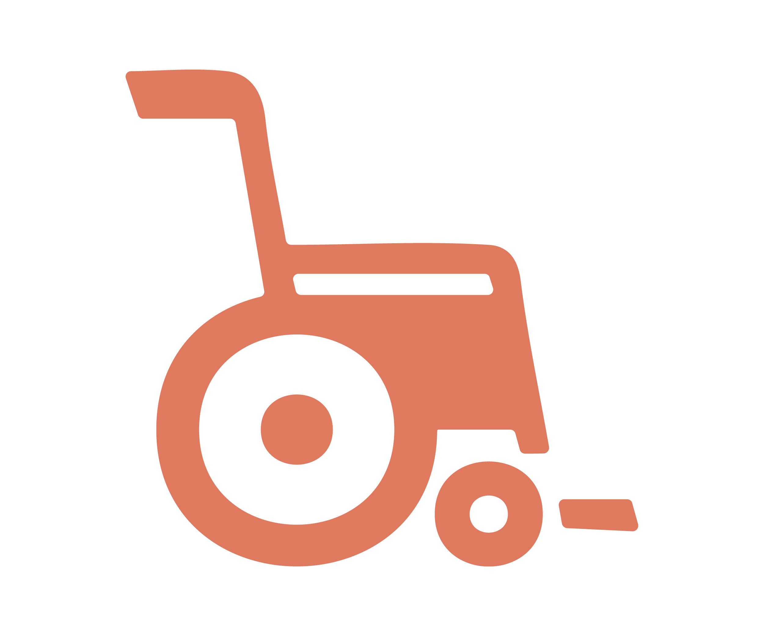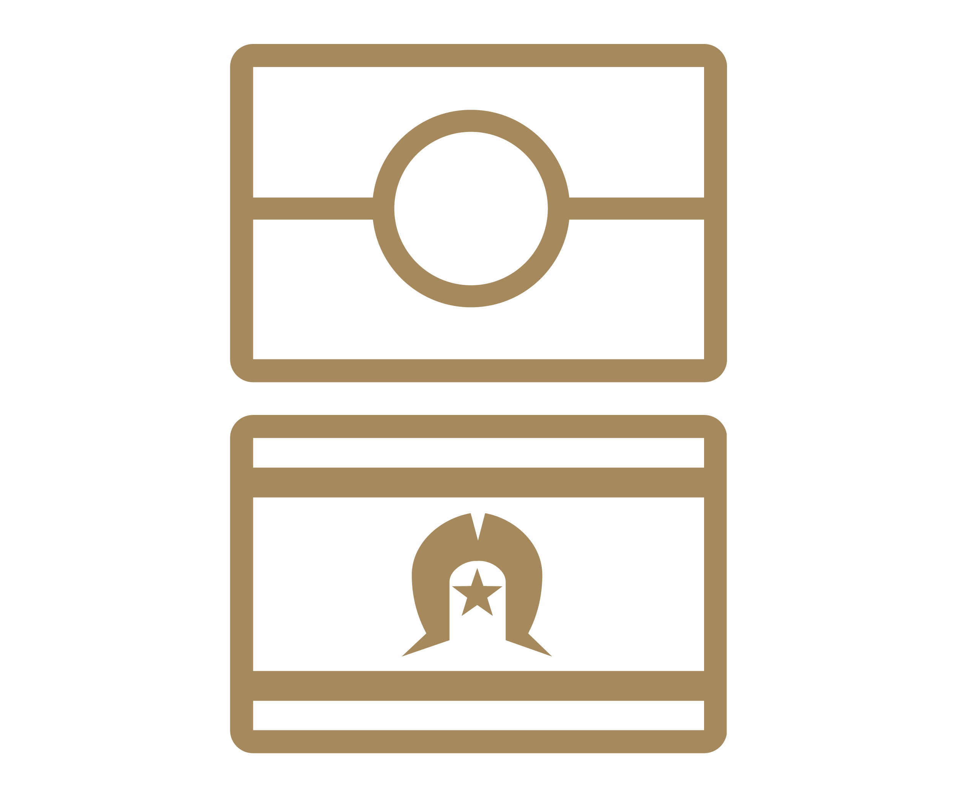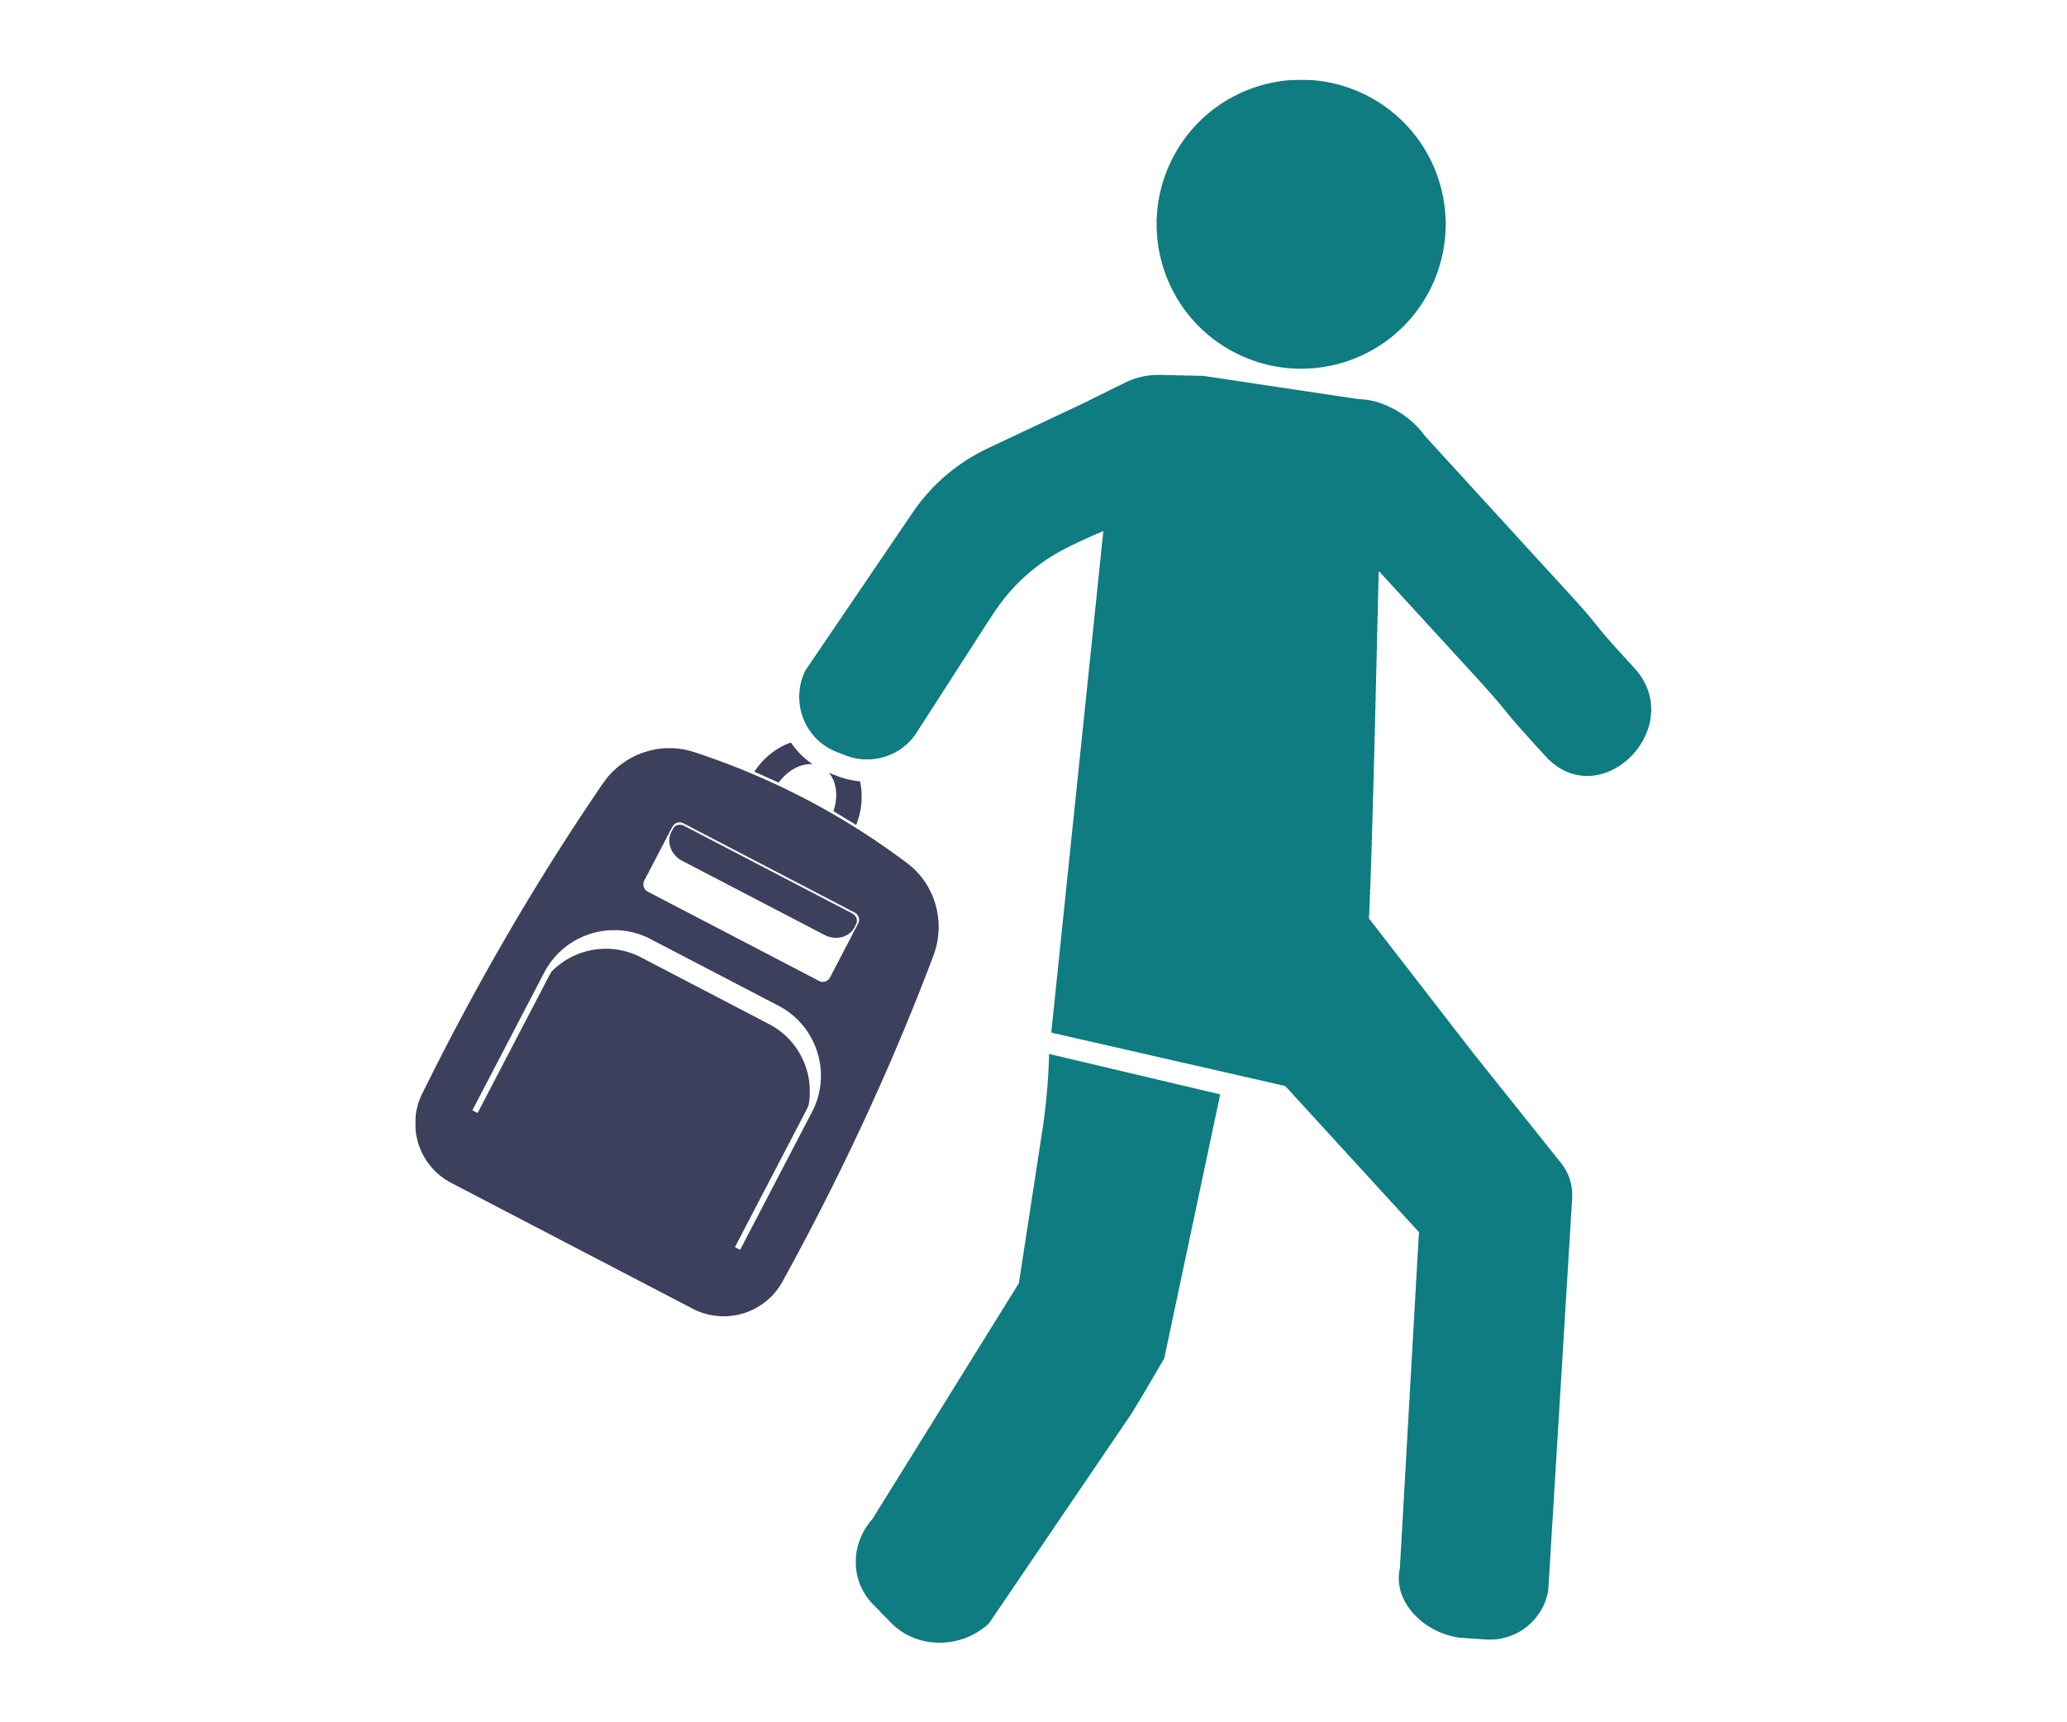

Reducing gender inequality and other forms of discrimination and disadvantage that exist in society, and in the workplace, is key to preventing workplace sexual harassment.

# Other workplace rights

Australian laws say that everyone has the right to be safe at work. Workplace sexual harassment is against the law. It is also against the law for your employer to treat you unfairly, or to punish you, because you:

* made, or did not make, a complaint about workplace sexual harassment
* proposed to make a complaint
* helped someone else make a complaint
* raised an issue about sexual harassment in your workplace.

Some examples of unfair treatment include:

* ending your employment
* offering you fewer shifts or fewer hours
* not allowing you to attend training
* threatening you to try to stop you from making a complaint.

# Workplace responsibilities

Your employer has a responsibility to do everything they reasonably can to make sure your workplace is safe. This includes taking action to prevent, and respond to, workplace sexual harassment.

Work health and safety laws place responsibilities on organisations, workers and others in a workplace to take steps to prevent and address sexual harassment.

* **Employers** have a responsibility to do everything they reasonably can to make sure the workplace is safe. This includes taking action to prevent, and respond to, workplace sexual harassment.
* **Officers** (key decision makers) must exercise due diligence to ensure that the organisation complies with WHS obligations.
* **Workers** are responsible for taking reasonable care of their own health and safety while at work, and not negatively impacting the health and safety of others. This includes not sexually harassing others and following reasonable instructions from their employer.
* **Others** **in the workplace** (including customers, clients and patients) are responsible for taking reasonable care of their own health and safety, and not negatively impacting the health and safety of others. This includes not sexually harassing others and following reasonable instructions relating to health and safety.

# What to do if you are sexually harassed at work

There is no one right way to respond to sexual harassment, just like there is no wrong way to respond. We all react to stress and trauma differently. Remember, if you are sexually harassed at work, it is not your fault.

**Common responses to stress: Flight, fight, freeze or fawn**

f5f2de

When we feel threatened, our body’s automatic stress response takes over and we enter survival mode. This is not something that we can control; our bodies do this automatically to try to protect us.

People generally respond to threats by fighting, fleeing (running away), freezing (shutting down) or fawning (trying to please the person threatening them in an attempt to make the threat stop). Freezing and fawning are normal responses to a threat or stress. If a person does not fight back or run away when they are being harassed, this does not mean that they allowed or encouraged the harassment to happen.

**Regardless of how a person responds, if a person is sexually harassed, it is not their fault.**

If you are sexually harassed at work there are a number of things you can do, on your own, or with help from others. Some of the things you can do include:

* **Remove yourself from the situation** by logging off your device, hanging up the phone, or walking away.
* **Call the police** on 000 if you feel unsafe. You can also call the 24/7 Police Assistance Line on 131 444 to report a crime.
* **Ask for help** from your co-workers, manager, friends, parents or other family members or a trusted adult.
* **Seek professional help** from a counselling service or helpline.
* **Keep a record** of what happened, when and where it happened, who was involved and anything else you think may be important, in case you wish to make a complaint or report (now or at a later date). If the harassment occurred on the phone or social media, consider taking screenshots as evidence of the harassment.
* **Ask for advice about your workplace rights:** There are government and non-government organisations that can provide you with free advice about workplace sexual harassment, including your options for making a complaint. For more information, see ‘Free and confidential advice about your options’.
* **Make an internal complaint or report** to management or human resources (as outlined in your workplace’s relevant policy or procedure, if they have one). For more information, see ‘Make a formal internal complaint’.
* **Make a report to a government agency** There are independent organisations that can accept complaints of workplace sexual harassment, such as the Australian Human Rights Commission or your state or territory’s human rights/anti-discrimination agency. For more information see ‘Government agencies that accept workplace sexual harassment complaints’.
* **Apply for a stop sexual harassment order from** the [Fair Work Commission](https://www.fwc.gov.au/issues-we-help/sexual-harassment/apply-stop-sexual-harassment-work) if you think the workplace harassment is likely to continue and you are still in the same workplace. The Commission can order that the sexual harassment at work stop, an apology be made or that support or training in the workplace is provided.



It is up to you to decide what you want to do, based on what you feel is best for you.

# Getting help

## ""Health and wellbeing support

Workplace sexual harassment can have significant impacts on the health and wellbeing of any person who experiences or witnesses it. You can access a range of free support services, including:

* 1800RESPECT offers confidential counselling and support, 24/7.

Phone: 1800 737 732 Website: [1800respect.org.au](https://www.1800respect.org.au/)

* Lifeline offers 24-hour crisis support and suicide prevention services.

Phone: 13 11 14 Website: [lifeline.org.au](https://www.lifeline.org.au/)

* 13Yarn offers 24/7 culturally safe crisis support for Aboriginal and Torres Strait Islander people.

Phone: 13 92 76 Website: [13yarn.org.au](http://www.13yarn.org.au)

* Mensline offers free confidential counselling and support for men.

Phone: 1300 78 99 78 Website: [mensline.org.au](http://www.mensline.org.au/)

* Headspace provides support to young people aged between 12 and 25 years.

Phone: 1800 650 890 Website: [headspace.org.au](http://www.headspace.org.au)

* Kids Helpline is a counselling service for children and young people aged between 5 and 25 years.

Phone: 1800 55 1800 Website: [kidshelpline.com.au](https://kidshelpline.com.au/)

* Your workplace may have an Employee Assistance Program (EAP) that can provide support. Ask your manager if you have an EAP.
* Your GP can provide you with advice and referrals to support services to suit your needs.

## ""Free and confidential advice about your options

Sometimes it can be hard to know where to go for help and how to make a complaint. You can contact any of the following services for free, confidential advice related to workplace sexual harassment:

* The Australian Human Rights Commission's free and confidential National Information Service can provide information and referrals in relation to workplace sexual harassment.

Phone: 1300 656 419 Email: [infoservice@humanrights.gov.au](mailto:infoservice@humanrights.gov.au)

Website: [humanrights.gov.au](http://www.humanrights.gov.au)

* Your local Community Legal Centre can provide options for free legal help.

To find your local centre: [clcs.org.au/findlegalhelp](http://www.clcs.org.au/findlegalhelp)

* Working Women's Centres provide information, advocacy, support and advice to women on work related issues (available in QLD, NT, SA only). To find the centre in your state or territory: [wwc.org.au//index.php?page=contact-us](https://australianhrc.sharepoint.com/sites/PolicyExternalProjects/SDT_Strategic_Advocacy_21_22/R@W%20Implementation/Recs%209,%2034,%2036,%2037,%2040%20-%20Edu%20and%20Training/_Education%20resources/Fact%20sheets/Working%20Drafts/2022%20drafts/wwc.org.au/index.php?page=contact-us).
* The [Australian Unions Support Centre](https://support.australianunions.org.au/hc/en-au/requests/new) provides free and confidential assistance about workplace issues.

Phone: 1300 486 466 Email: [help@actu.org.au](mailto:help@actu.org.au)

Website: [support.australianunions.org.au](https://support.australianunions.org.au/hc/en-au)

* The Fair Work Commission can provide information about your workplace rights and can issue a stop sexual harassment order.

Phone: 1300 799 675 Website: [fwc.gov.au](https://www.fwc.gov.au/)

If you need an interpreter, call the [Telephone Interpreter Service (TIS)](https://www.tisnational.gov.au/) on 131 450.

If you are deaf and/or find it hard hearing or speaking with people who use a phone, the National Relay Service (NRS) can help you. For support options visit the [National Relay Service website](https://www.infrastructure.gov.au/media-communications-arts/phone/services-people-disability/accesshub/national-relay-service).



# ""Reporting workplace sexual harassment

You also have the option of reporting workplace sexual harassment. There are both internal (within your workplace) and external (outside your workplace) reporting options.

## Informal reporting options

Complaint and report:

We are using the word report here, but some organisations use the word ‘complaint’ instead. In this context, they mean the same thing. Sometimes an informal complaint or report is called a ‘disclosure.

### Address the harassment yourself

If you feel safe:

* Speak to the person who harassed you.
* Let them know their behaviour makes you uncomfortable.
* Calmly explain why their behaviour is unacceptable.
* Taking this option may give the harasser an opportunity to change their actions.
* This option works best if you believe the harasser does not realise how their behaviour affects you.
* If you are worried that the harasser might react negatively, you may want to ask someone else for help.

### Ask for help to address the harassment

If you do not feel comfortable talking to the harasser on your own but do not wish to make a formal complaint:

If the harasser is your manager:

If the person who is sexually harassing you is your manager, there are other people you can ask for help. For example, you could speak to another manager, your manager’s manager or another senior person and ask them for help. You could also ask for help from your human resources team. If you do not feel comfortable speaking to anyone in your own workplace, there are other organisations that can help.

* Ask a trusted co-worker or manager to have a private conversation with the harasser about their behaviour.
* This option works best if you have a clear idea of what you would like to happen when you ask for help.
* It is possible that the person you ask for help may have a different opinion to you on how the harassment should be dealt with. For example, if the harasser's behaviours are repeated or likely to affect others in the workplace, management may need to take more direct action to ensure both your safety, and the safety of your co-workers.
* Employers have a legal responsibility to do everything they reasonable can to make the workplace safe.
* Even if this is the case, it is important that your safety and wishes are respected and that management are honest with you about what they plan to do.

## Formal reporting options

You may also choose to make a formal report about workplace sexual harassment. You can make an:

* internal report (within your organisation)
* external report (with an independent organisation).

If you make a formal report:

* It may require a formal investigation, where information is gathered about the circumstances of the harassment.
* A formal report can result in several possible outcomes, such as an apology, compensation, a change in policy, an agreement to provide training for staff or terminating the employment of the harasser.
* It is important to know that if you are making a formal report, the harasser will probably be told about the complaint against them and usually will have the opportunity to respond. This is to ensure that the process is as fair as possible for everyone involved.
* If the harasser (or your employer) punishes you or treats you unfairly because you made a report about them, this is against the law.

You have the right to make up your own mind about what you choose to do. You may decide you do not wish to make a formal report or take any action.

It is important to remember that no one should force you, or try to persuade you, to make a report if you do not want to. Likewise, no one should force you, or try to persuade you, *not* to make a complaint.

### Internal reporting

* Some workplaces have policies that explain how to make an internal complaint about bullying, harassment and discrimination.
* Some workplaces have dedicated sexual harassment policies and procedures.
* If you do not know if your workplace has a sexual harassment policy or complaints process, you can ask a co-worker, your manager or your human resources department for more information.
* The complaints process is different for each organisation but it may involve making a complaint to your manager, human resources or a health and safety representative.
* If you make an internal complaint, the complaint will be managed by your organisation and follow the organisation’s workplace policies.

### External reporting

* You also have the option of making a workplace sexual harassment report to an external agency.
* You may choose to do this for several reasons, including:
  + your organisation does not have a clear reporting process
  + you are unhappy with the way your internal report has been dealt with
  + you do not feel comfortable making an internal report.
* There are several government agencies that can accept reports of workplace sexual harassment.

## Agencies that accept reports of workplace sexual harassment complaints

Each of the agencies listed below have responsibilities and powers to address workplace sexual harassment. If you would like advice about which agency might be best for your situation, contact one of the organisations listed in the ‘Free and confidential advice about your options’ section.

**The police**

If you believe the workplace sexual harassment you have experienced involves criminal conduct, including actual or attempted sexual assault, you can report the matter to police.

The Police Assistance Line operates 24 hours a day, 7 days a week and allows you to report a crime over the phone. That information is then made immediately available to your local police. You can call the service on 131 444 and find further information on the website (www.aic.gov.au/contact-us/report-crime).

If you, or someone else, is in immediate danger you should call the police on 000

**Human rights, anti-discrimination or equal opportunity agencies**

The following agencies can investigate reports about human rights breaches and discrimination, including workplace sexual harassment:

* Australian Human Rights Commission (National body)

Phone: 1300 369 711 Email: [infoservice@humanrights.gov.au](mailto:infoservice@humanrights.gov.au)

Website: [humanrights.gov.au](http://www.humanrights.gov.au/)

* ACT Human Rights Commission

Phone: (02) 6205 222 Email: [human.rights@act.gov.au](mailto:human.rights@act.gov.au)

Website: [hrc.act.gov.au](http://www.hrc.act.gov.au)

* Anti-Discrimination New South Wales

Phone: 1800 670 812 Email: [complaintsadb@justice.nsw.gov.au](mailto:complaintsadb@justice.nsw.gov.au)

Website: [antidiscrimination.nsw.gov.au](http://www.antidiscrimination.nsw.gov.au/)

* Northern Territory Anti-Discrimination Commission

Phone: 1800 813 846 Email: [antidiscrimination@nt.gov.au](mailto:antidiscrimination@nt.gov.au)

Website: [adc.nt.gov.au](https://adc.nt.gov.au)

* Queensland Human Rights Commission

Phone: 1300 130 670 Email: enquiries@qhrc.qld.gov.au

Website: [qhrc.qld.gov.au](https://www.qhrc.qld.gov.au/)

* SA Office of the Commissioner for Equal Opportunity

Phone: (08) 7322 7070 Email: OCEO@sa.gov.au

Website: [eoc.sa.gov.au](https://www.eoc.sa.gov.au)

* Equal Opportunity Tasmania

Phone: 1300 305 062 Email: [office@equalopportunity.tas.gov.au](mailto:office@equalopportunity.tas.gov.au)

Website: [equalopportunity.tas.gov.au](http://www.equalopportunity.tas.gov.au)

* Victorian Equal Opportunity and Human Rights Commission

Phone: 1300 292 153 Email: enquiries@veohrc.vic.gov.au

Website: [humanrights.vic.gov.au](http://www.humanrights.vic.gov.au)

* WA Equal Opportunity Commission

Phone: 1800 198 149 Email: eoc@eoc.wa.gov.au

Website: [wa.gov.au/organisation/equal-opportunity-commission](http://www.wa.gov.au/organisation/equal-opportunity-commission)

**Fair Work Commission**

If you have been treated unfairly, or punished, by your employer because you reported sexual harassment, you may be able to make a complaint to the [Fair Work Commission](https://www.fwc.gov.au/issues-we-help/sexual-harassment). In certain circumstances, they also have the power to issue a 'stop sexual harassment order' to try to stop the harassment from continuing. For more information or to check your eligibility, contact the Fair Work Commission.

Phone: 1300 799 675 Website: [www.fwc.gov.au](http://www.fwc.gov.au)

**Fair Work Ombudsman**

The Fair Work Ombudsman is Australia’s national workplace relations regulator. It provides employees and employers with information and advice about workplace entitlements and obligations.

The Fair Work Ombudsman can provide employees and employers with general information about protections from sexual harassment, prevention and managing sexual harassment in the workplace.

Phone: 13 13 94 Website: [www.fairwork.gov.au](http://www.fairwork.gov.au)

**Work, Health and Safety (WHS) regulators**

Everyone has the right to be safe at work. Your employer has a responsibility to provide you with a safe working environment. The [WHS regulator in your state or territory](https://www.safeworkaustralia.gov.au/law-and-regulation/whs-regulators-and-workers-compensation-authorities-contact-information)may be able to investigate whether your employer is doing all they need to do to provide its workers with a safe working environment. You can also contact your WHS regulator if you feel you have been treated unfairly, or punished, because you raised concerns about workplace sexual harassment.

You can find your state or territory’s WHS regulator on the Safe Work Australia website: [www.safeworkaustralia.gov.au/law-and-regulation/whs-regulators-and-workers-compensation-authorities-contact-information](https://www.safeworkaustralia.gov.au/law-and-regulation/whs-regulators-and-workers-compensation-authorities-contact-information)

For more information:

The Respect@Work website provides free information about workplace sexual harassment. To find out more, visit [www.respectatwork.gov.au/younger-workers](http://www.respectatwork.gov.au/younger-workers)

f5f2de