## In this document:

1. The definition of sexual harassment
2. The definition of workplace sexual harassment
3. Other workplace rights

This resource includes information for younger workers about workplace sexual harassment and how you can respond to it if it happens to you or a friend or co-worker. Remember: **if you, or someone else, is in immediate danger you should call the police on 000. If there is no immediate danger but you or someone else needs police assistance, phone 131 444.**

Workplace sexual harassment is against the law.

# The definition of sexual harassment

In simple terms, sexual harassment means any unwelcome sexual behaviour that a reasonable person could anticipate may make another person feel offended, humiliated or intimidated in that situation

A **‘reasonable person’** can be taken to mean a neutral and unbiased observer.

Sexual harassment is not always obvious. It includes a wide range of behaviours. The most common behaviours are:

* sexually suggestive comments or jokes that offend or intimidate
* intrusive questions about private life or physical appearance
* inappropriate staring or leering
* inappropriate physical contact
* unwelcome touching, hugging, cornering or kissing.

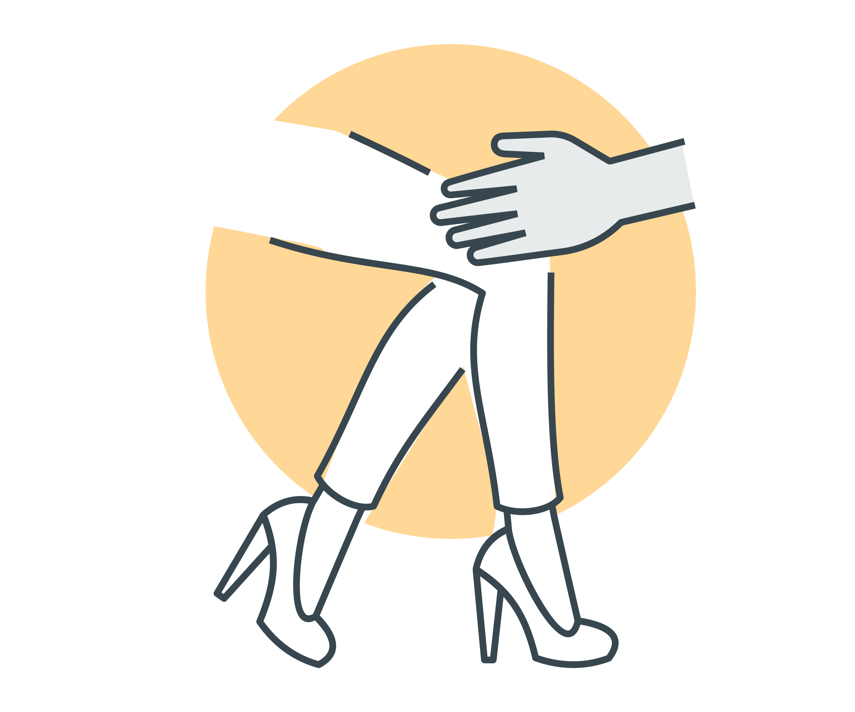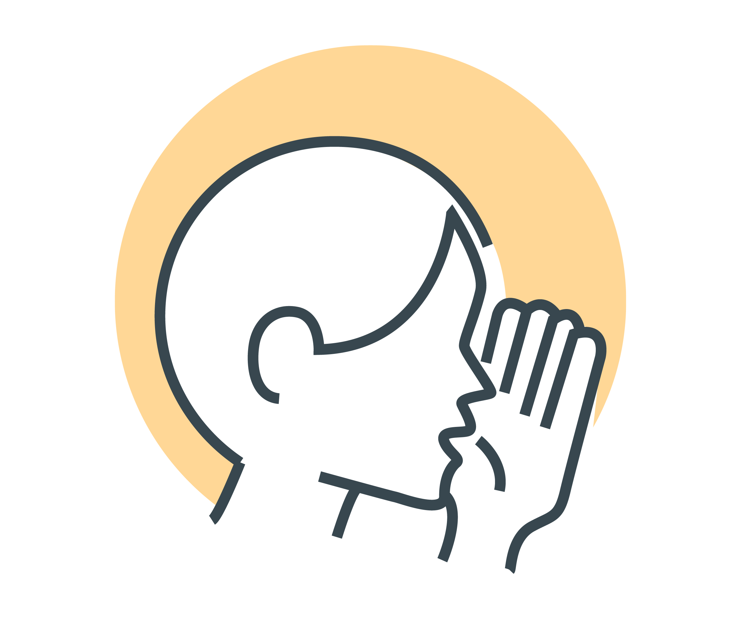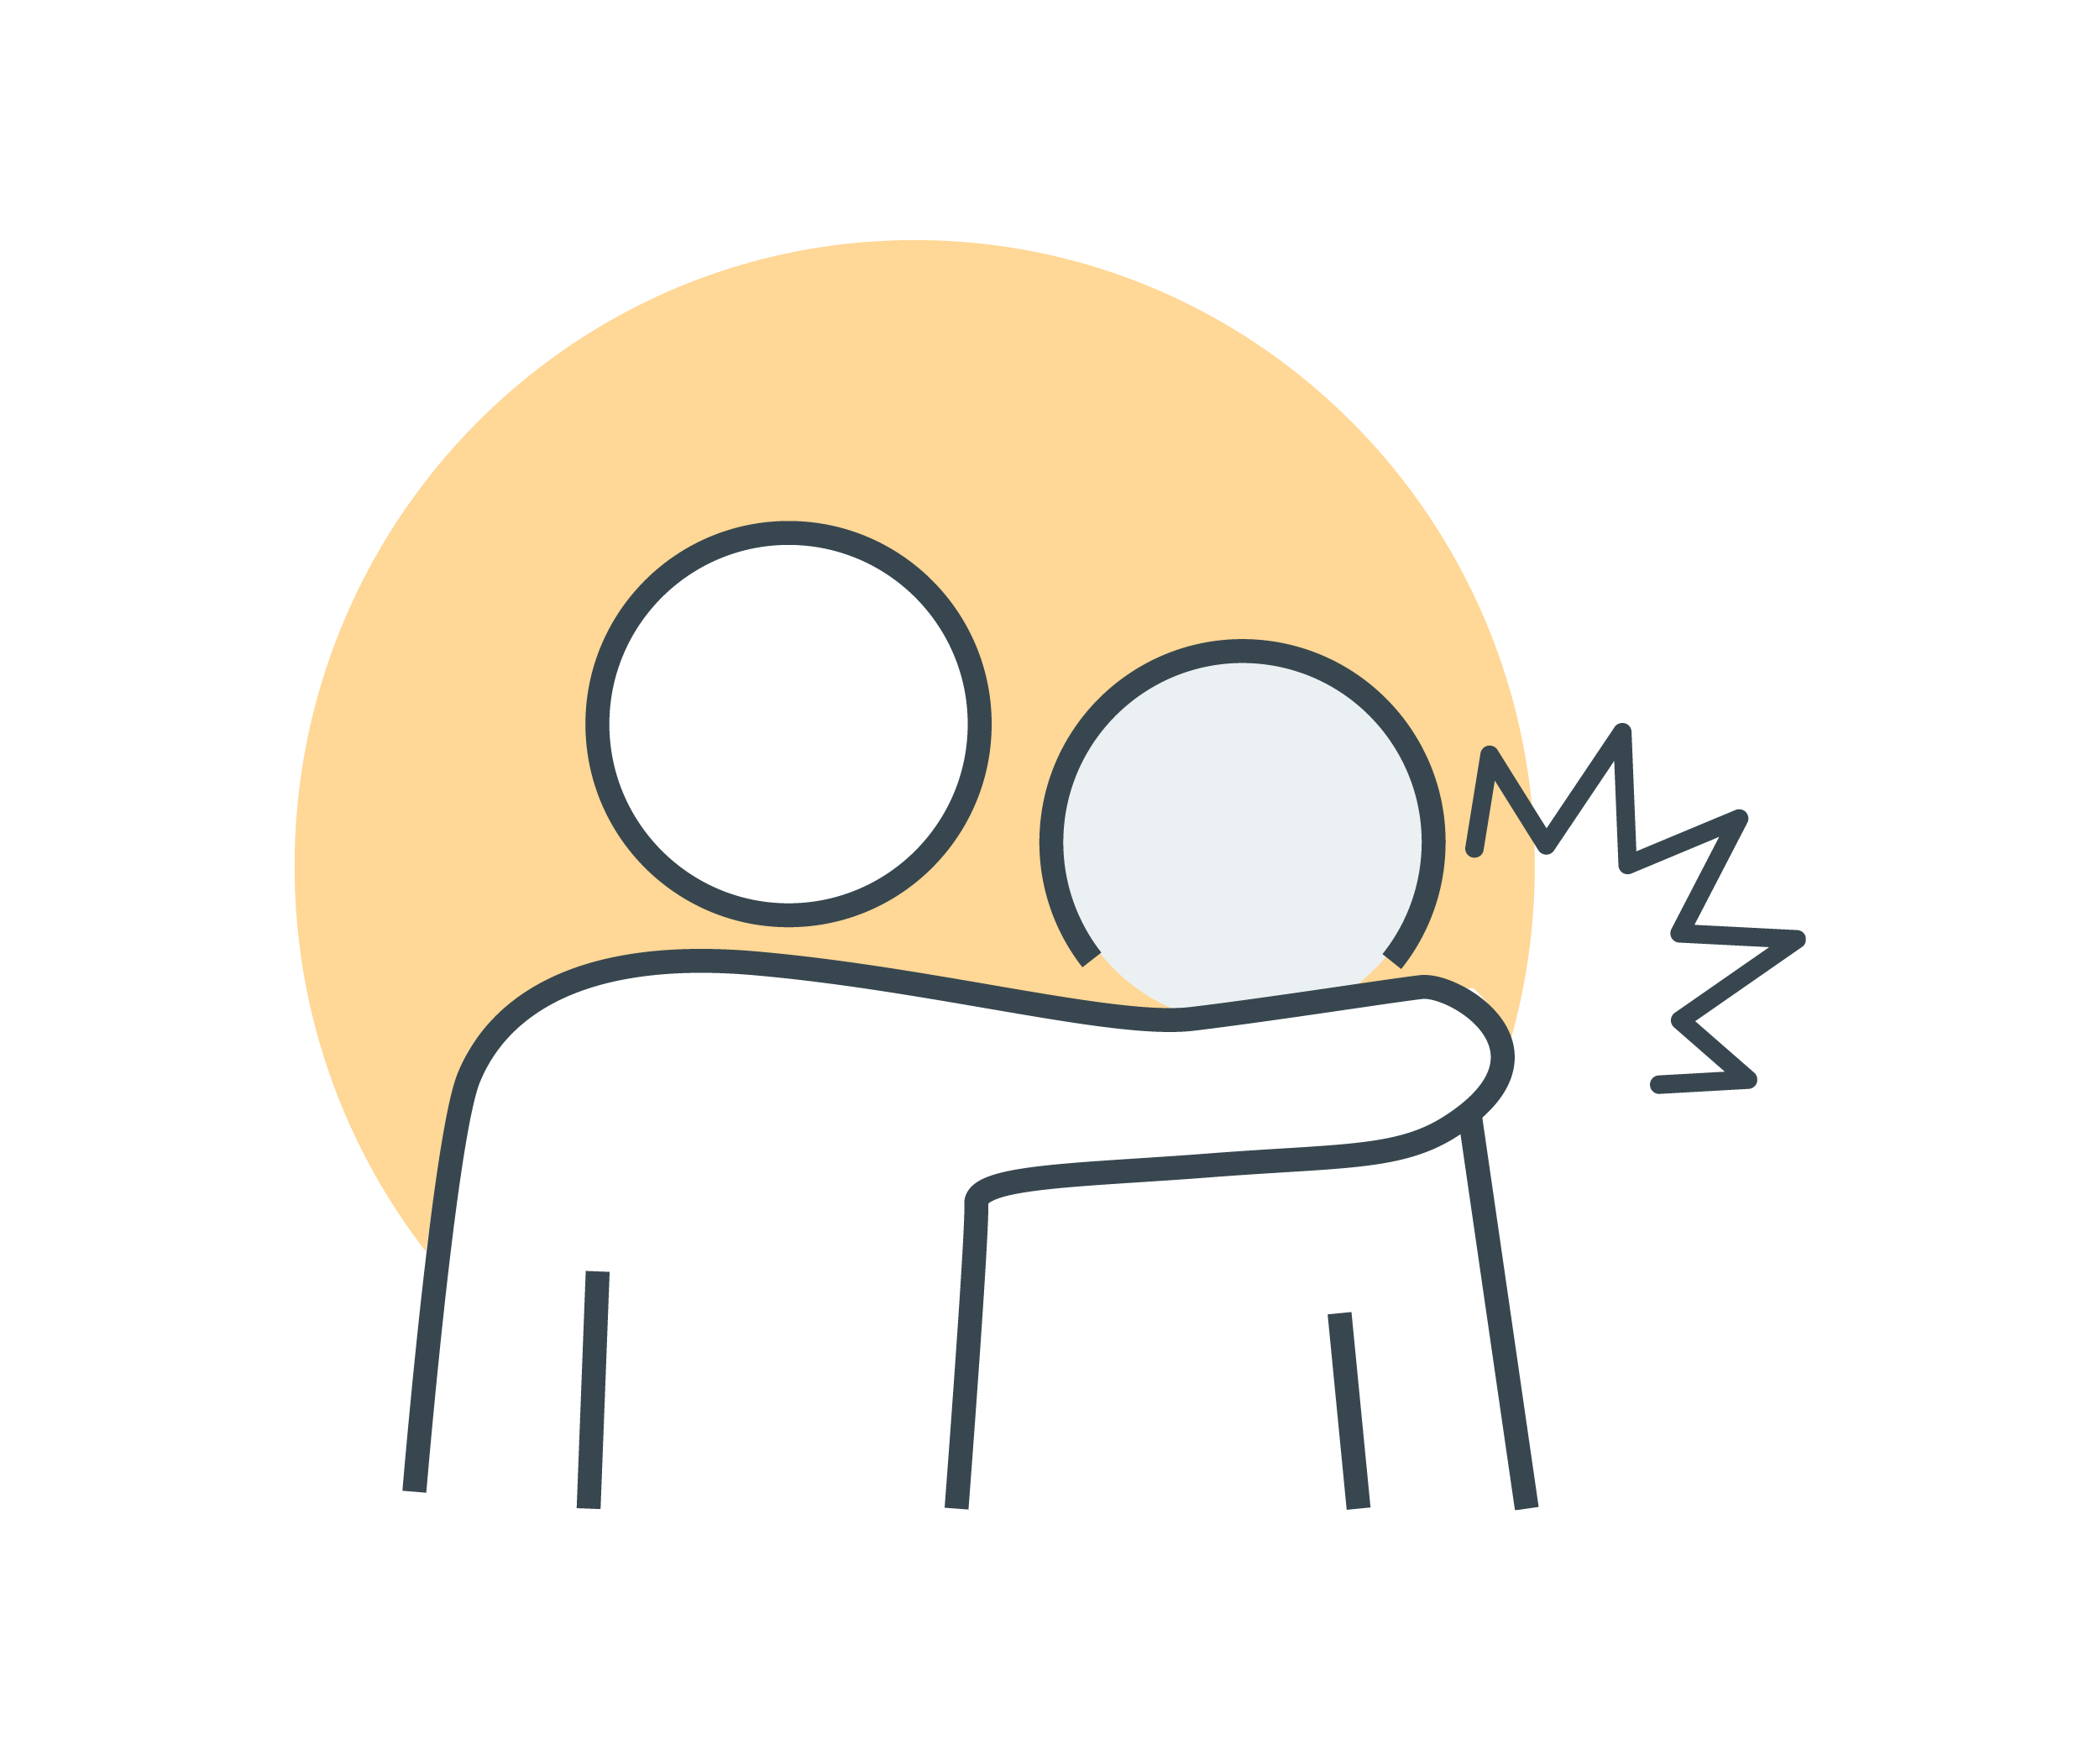

Other examples of sexual harassment include:

* sharing or threatening to share intimate images or video without consent
* images or videos that are sexually suggestive or that constitute a sexual advance
* repeated or inappropriate invitations to go out on dates
* requests or pressure for sex or other sexual acts
* sexually explicit gifts, images, videos, cartoons, drawings, photographs, or jokes
* actual or attempted rape or sexual assault
* being followed or watched inappropriately, or someone loitering inappropriately, either in person or via technology
* sexually explicit comments made in person or in writing, or indecent messages (SMS, social media), phone calls or emails—including the use of emojis with sexual connotations
* sexual gestures, indecent exposure or inappropriate display of the body
* technology-facilitated unwelcome conduct of a sexual nature—including on virtual meetings
* repeated or inappropriate advances on email or other online social technologies.

Sexual harassment happens in person, over the phone and online, including via social media.



# The definition of workplace sexual harassment

If sexual harassment occurs at, or in connection with, work then it is against the law.

Sexual harassment is against the law if it happens:

* between individuals who have a particular workplace relationship, or
* during work, or in connection with work.

A ‘**worker’** is anyone who carries out work for an employer or business. This includes full-time, part-time and casual workers, workers on probation, contract-based workers, self-employed workers, interns, apprentices, students and volunteers (unless the organisation is run entirely by volunteers).

### Workplace relationships

Regardless of whether it happens in the workplace, or elsewhere, it is against the law for:

* an employer to sexually harass a worker, or anyone seeking to become a worker
* a worker to sexually harass another worker*, or anyone seeking to become a worker.

* Another worker could be a manager. It could also be a worker who is more senior, less senior, or at the same level as you.

### In connection with the workplace

There are also people other than workers and employers in the workplace (for example, clients, customers and contractors). The law protects you from workplace sexual harassment by these people as well). A workplace includes any place where work is done and includes any place where a worker goes, or is likely to be, while working. This includes:

* your main place of work (for example, a store, office or business)
* common areas (for example lifts, reception areas, corridors, kitchens and bathrooms)
* your home or another location, if you are working remotely
* agency or on-call work (for example, where you travel to different places or other people’s homes to do your work)
* conferences, training and other professional development programs, whether onsite or offsite
* transportation, travel and accommodation, if you are travelling for work
* work social and networking events.

If you are sexually harassed while you are at any of these places in connection with your work, it can still be against the law.

# Other workplace rights

Australian laws say that everyone has the right to be safe at work. Workplace sexual harassment is against the law. It is also against the law for your employer to treat you unfairly, or to punish you, because you:

* made, or did not make, a complaint about workplace sexual harassment
* proposed to make a complaint
* helped someone else make a complaint
* raised an issue about sexual harassment in your workplace.

Some examples of unfair treatment include:

* ending your employment
* offering you fewer shifts or fewer hours
* not allowing you to attend training
* threatening you to try to stop you from making a complaint.

Your employer has a responsibility to do everything they reasonably can to make sure your workplace is safe. This includes taking action to prevent, and respond to, workplace sexual harassment.

Workers are responsible for taking reasonable care of their own health and safety while at work, and not negatively impacting the health and safety of others. This includes not sexually harassing others and following reasonable instructions from their employer relating to health and safety.

For more information:

The Respect@Work website provides free information about workplace sexual harassment. To find out more, visit [www.respectatwork.gov.au/younger-workers](http://www.respectatwork.gov.au/younger-workers)

f5f2de