ADKAR tool for positive cultural change

Culture change relies on the active participation of a critical mass of your workforce. Approaches to stakeholder engagement and change management will vary depending on your organisation’s size, resources and available expertise.

An example of a change management model is the ADKAR (Awareness, Desire, Knowledge, Ability, Reinforcement) model, which acknowledges that effective change happens one person at a time and is a useful tool to plan how you will achieve collective ownership of culture change.

[insert RW_030_ADKAR]

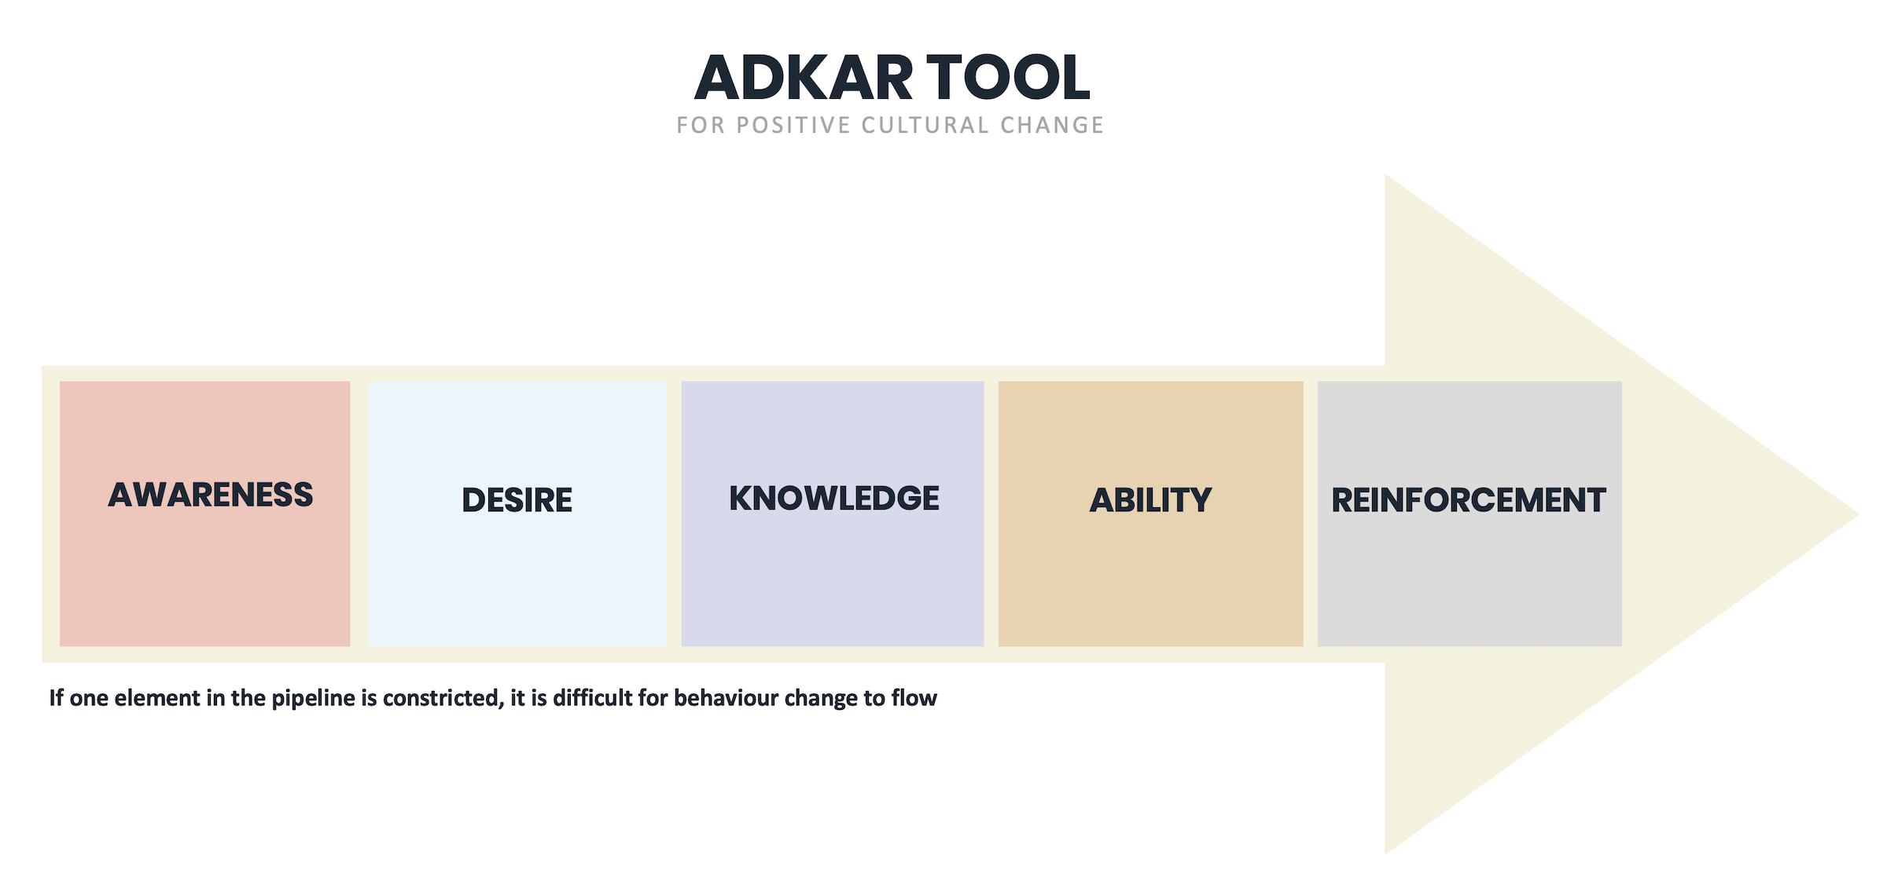

Dimension | Measure of success | Actions to address gaps
Awareness  Generate awareness of organisation’s commitment to prevent sexual harassment. | - Leaders and workers are aware that your organisation is committed to positive culture change and has zero tolerance for sexual harassment, disrespectful behaviours and all forms of discrimination | - Use multiple communication channels to explain your organisation’s commitment to a harassment-free workplace (intranet, leader communications, relevant codes / policies)  - Reinforce commitment to harassment-free workplace during recruitment and selection process.
Desire  Foster a desire to learn more and contribute to positive culture change. | - Leaders and workers are genuinely interested in understanding the organisation’s commitment to prevent sexual harassment at work.  - There is a desire to contribute to positive change. | - Use storytelling and data to communicate the need for change.  - Equip senior leaders to sponsor your culture change.  - Set-up a “champion network” of committed employee to advocate for change.
Knowledge  Clarify acceptable and unacceptable behaviours. | - Leaders and workers understand:  - Values in action, including acceptable and unacceptable behaviours.  - How they can personally contribute to a harassment-free workplace | - Deliver mandatory training to clarify acceptable and unacceptable behaviours and everyone’s role contributing to a harassment-free workplace.  - Provide toolkits that explain what people are expected to “know, be and do” in support of the values.
Ability  Develop skills to deliver culture change and role model acceptable behaviours. | - Leaders have the ability to role model and promote the values and behaviours.  - Values and behaviours inform key decisions.  - Workers have the ability to demonstrate values and behaviours | - Leadership development  - Coaching tools for leaders  - Introduce practical resources to enable leaders and workers to demonstrate the values everyday, For example:  - Values based conversations  - Values based meeting  - Values based decisions
Reinforcement  Reinforce positive change and acceptable behaviours on an ongoing basis | - Values and behaviours continue to be role modelled and positively reinforced by leaders and workers  - There is a monitoring and planning cycle in place to maintain positive culture change | - Include values and behaviours in management practices to consistently reinforce their importance.  - Publicly recognise values and behaviours and share stories in support of this on an ongoing basis.  - Regularly share culture insights to reinforce positive cultural norms and address areas of concern.

